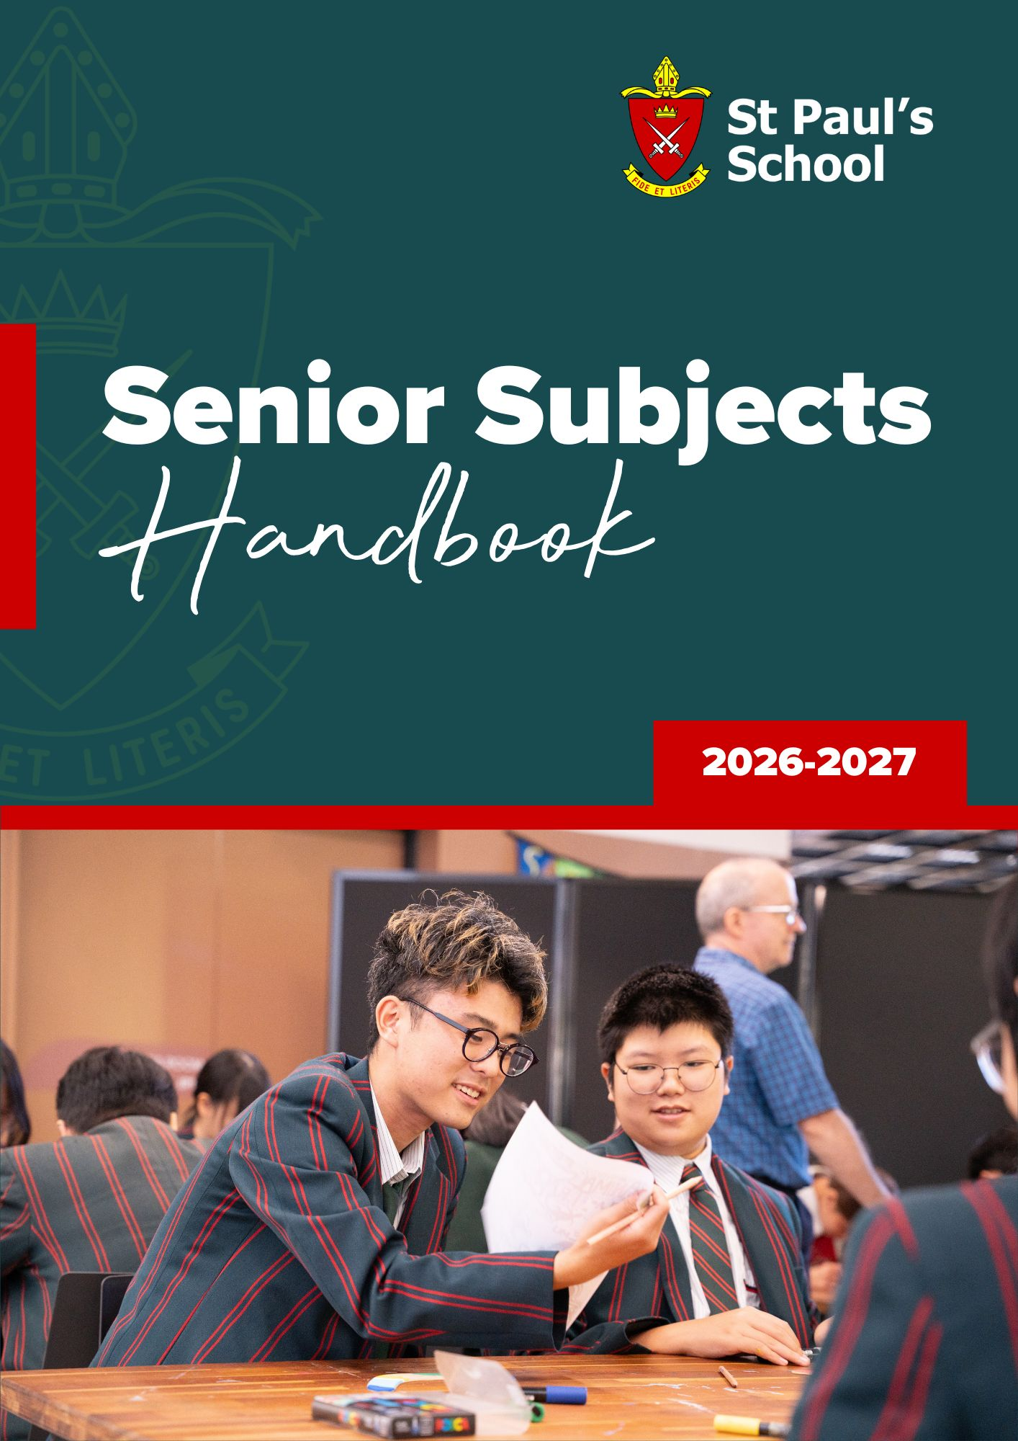
Table of Contents
Preparing for the Senior Phase of Learning 4
Senior Education & Training (SET) Plan 4
Queensland Certificate of Education (QCE) 5
QCE Requirements 5
Australian Tertiary Admission Rank (ATAR) 5
Senior School Pathways 6
QCE & ATAR Tertiary Student Pathway (ATAR eligibility) 6
QCE & ATAR Pathway (ATAR eligibility and Vocational qualifications) 6
QCE & Vocational Pathway (Vocational Certificates and Work Experience) 6
Types of Subjects 7
General Subjects 7
Applied Subjects 7
Vocational Education and Training (VET) 7
University Head Start Program 7
Subject Listing by Learning Areas 8
English 9
English | General Subject 10
English & Literature Extension (Year 12 Only) | Extension Subject 12
Essential English | Applied Subject 14
Literature | General Subject 16
Mathematics 18
Essential Mathematics | Applied Subject 19
General Mathematics | General Subject 21
Mathematical Methods | General Subject 23
Specialist Mathematics | General Subject 25
The Arts 27
Drama | General Subject 28
Music | General Subject 30
Music Extension (Year 12 Only) | Extension Subject 32
Visual Art | General Subject 35
Visual Art in Practice| Applied Subject 37
Cert III in Music – CUA30920 | VET Subject 39
Technologies 41
Design | General Subject 42
Digital Solutions | General Subject 44
Engineering Skills | Applied Subject 46
Food & Nutrition | General Subject 48
Industrial Technology Skills | Applied Subject 50
Information & Communication Technology | Applied Subject 52
Cert III in Hospitality – SIT30616 | VET Subject 54
Sciences 56
Biology | General Subject 57
Chemistry | General Subject 59
Physics | General Subject 61
Psychology | General Subject 63
Humanities & Social Sciences 65
Accounting | General Subject 66
Business | General Subject 68
Economics | General Subject 70
Geography | General Subject 72
Legal Studies | General Subject 74
Modern History | General Subject 76
Languages 78
Chinese | General Subject 79
Japanese | General Subject 81
Languages SEE | General Subject 83
Health & Physical Education 85
Health | General Subject 86
Physical Education | General Subject 88
Cert III in Fitness - SIS30321 (Binnacle Training RTO 31319) | VET Subject 90
Cert II in Sport and Recreation - SIS20122 (Binnacle Training RTO 31319) | VET Subject 90
Vocational Education & Training (VET) 94
Vocational Education & Training (VET) | VET in Schools 95
School Based Subjects/QCAA Recognised Studies 97
English Language Development Program | School-Based Subject 98

Please note: information in this handbook is subject to change.

Preparing for the Senior Phase of Learning
The transition into the senior phase of learning marks an important step in each student’s educational journey, where subject choices play a significant role in shaping future study, training, and career pathways. This handbook has been designed to support students, and their parents and caregivers, as they begin the process of selecting subjects for Years 11 and 12.
In the senior years, students are offered greater flexibility and autonomy in their learning. With this comes the responsibility to choose subjects that align with their individual interests, strengths, and long-term aspirations—whether they plan to attend university, pursue vocational education and training (VET), undertake an apprenticeship, or enter the workforce.
This handbook provides essential information about the subject offerings available at St Paul’s School, explains the requirements for achieving the Queensland Certificate of Education (QCE) and Australian Tertiary Admission Rank (ATAR) eligibility. Students are encouraged to use this information to reflect on their goals, explore a variety of options, and seek guidance from their teachers, the Head of Career Pathways, and parents or caregivers to support their subject selections.
The senior phase is not only about completing school—it is about building a strong foundation for future opportunities. Through careful planning and informed subject selection, students can set themselves up for success in whatever pathway they choose to pursue.

Senior Education & Training (SET) Plan
The Senior Education and Training Plan (SET Plan) helps each student structure their senior learning around their abilities, interests and ambitions. SET Plans are completed, together with Year 11 subject selections, during Term 2, Year 10. The SET plan is agreed between the student, their parents/caregivers and the School. SET Plans are also reviewed regularly during Years 11 and 12.

When developing a SET Plan and making subject selections, students should choose subjects that they are interested in and those where they have experienced success. They should also consider:
- their long-term career goals
- the options (university, TAFE or work) that will assist them to achieve their chosen career
- the subjects that align best to their preferred career pathway/s
- the prerequisite subjects for tertiary or TAFE or VET courses that may be required
- QCE requirements
- ATAR eligibility

Queensland Certificate of Education (QCE)
The QCE is Queensland’s senior secondary schooling qualification. Awarded by the Queensland Curriculum and Assessment Authority (QCAA), it is internationally recognised and provides evidence of senior schooling achievements. Students who do not meet the requirements of the QCE at the end of Year 12 can continue to work towards their certificate after finishing Year 12, through the completion of additional learning such as vocational education and training courses or traineeships.

QCE Requirements
To be eligible for a QCE, students must:
- have an open learning account
- not have been previously issued with a QCE or equivalent
- accrue at least one credit from the Core Category of learning while enrolled at a Queensland school
To receive their QCE, students must then achieve the set amount of learning, at the set standard, in a set pattern, while meeting literacy and numeracy requirements.
Set amount
20 credits from learning options, including: | QCAA subjects or courses  Vocational education and training qualifications Non-Queensland studies  Recognised studies
Set standard
Satisfactory completion, grade of C or better, competency or qualification completion, pass or equivalent
Set pattern
12 credits from completed Core courses of study, and
8 credits from any combination of: | Core courses of study  Preparatory courses of study (max. 4) Complementary courses of study (max. 8)

For more information visit the QCAA website:
https://www.qcaa.qld.edu.au/senior/certificates-and-qualifications/qce/about-the-qce

Australian Tertiary Admission Rank (ATAR)
ATAR is the primary mechanism used nationally for tertiary admissions and indicates a student’s position relative to other students. It is the standard measure of a student’s overall academic achievement in relation to other students where these students have studied different subject combinations.
ATARs are expressed as a number on a 2000-point scale from 99.95 down to 0.00 in steps of 0.05. So, the highest ATAR is 99.95, then 99.90, then 99.85, and so on, down to 0.00. ATARs below 30 are reported as ‘30.00 or less’.
Students who intend to go to university should also plan their senior studies to meet the Queensland Tertiary Admission Centre (QTAC) eligibility requirements for an Australian Tertiary Admission Rank (ATAR).
To be eligible for an ATAR a student must attain satisfactory completion of one of the following QCAA English subjects:
- English
- Essential English
- Literature
- English and Literature Extension
They must also satisfactorily complete either of the following:
- 5 General Subjects
- 4 General Subjects plus one Applied Subject or a Certificate III or higher VET qualification.

For more information visit the QTAC website: https://www.qtac.edu.au/atar/

Senior School Pathways
The flexibility of the QCE and ATAR means that students can choose from a wide range of learning options to suit their interests and career goals. The pathways available to students at St Paul’s are outlined below.

QCE & ATAR Tertiary Student Pathway (ATAR eligibility)
Students who are interested in university studies will opt for this pathway. In this option, students select 6 General subjects for study in Years 11 and 12 or they may select a minimum of five General subjects plus 1 Applied subject or Certificate III or higher. A pass in an English subject is also mandatory.

QCE & ATAR Pathway (ATAR eligibility and Vocational qualifications)
Students who are interested in a blended pathway may still select subjects that prepare them for tertiary studies while also gaining experience and credit in a particular vocational field. A student’s program can be negotiated while still maintaining a minimum of five General subjects and a certificate course of a Certificate III or higher.

QCE & Vocational Pathway (Vocational Certificates and Work Experience)
Students who are interested in pursuing a vocational pathway can opt to undertake a range of subjects, from General and Applied subjects or Certificate courses. This program is negotiated at SET Planning to ensure students will still meet the mandatory QCE requirements.

Types of Subjects

General Subjects
These are subjects that the QCAA has developed to prepare students for further study on completion of school. A minimum of five of these subjects plus one from an Applied subject, Certificate III, or Certificate IV, or Diploma, or Advanced Diploma are required for the calculation of the ATAR. Alternatively, students may select all six of their subjects from the General Subjects available.

Applied Subjects
Applied subjects are more practical in nature, but they can also be used to attain a QCE and one Applied subject can be used in the calculation of an ATAR. These subjects are: Essential English, Essential Mathematics, Engineering Skills, Industrial Technology Skills and Visual Art in Practice. St Paul’s School offers three VET Courses delivered within the school timetable including Certificate III in Music, Certificate III in Hospitality, Certificate III in Fitness and Certificate II in Sport and Recreation.

Vocational Education and Training (VET)
VET courses can lead to nationally-recognised Australian Quality Framework (AQF) qualifications as either Certificates or Statements of Attainment. These courses provide students with workplace experience and skills whilst still at school. Students choosing external vocational subjects where they will be seeking to achieve nationally-endorsed competency standards need to check whether structured work placement or industry placement is a requirement. This will need to be considered as students will not be at school during these times and this may have an impact upon their learning in other subjects. Students are expected to negotiate alternative arrangements with relevant teachers. In selecting this option, students and parents/caregivers should strongly consider the student’s ability to work independently and manage their time effectively in order to catch up on work missed as a result of their out-of-school commitments.

University Head Start Program
Some universities offer Head Start programs for high achieving Year 11 and Year 12 students where they can complete one university subject whilst still at school. These programs aim to prepare students for university by experiencing classes, completing assessment and enjoying campus life. It can also be a great way to trial potential study areas. Students who successfully complete a Head Start program may receive credit for their completed course should they later enrol at the same university in that degree. The Head Start program also counts towards a student’s QCE. Students can study a wide range of programs including Business & Economics, People & Culture, Science, Maths and the Environment as well as Languages. In selecting this option, students and parents/caregivers should strongly consider the student’s ability to work independently and manage their time effectively in order to catch up on work missed as a result of their out-of-school commitments.

For more information, visit the universities:
- The University of Queensland “Enhanced Studies Program” - https://esp.uq.edu.au/
- Queensland University of Technology “Start QUT” - https://www.qut.edu.au/study/study- options/start-qut
- University of Sunshine Coast “USC Headstart Program” - https://www.usc.edu.au/learn/courses- and-programs/headstart-program-year-11-and-12-students
- Griffith University “Griffith University Headstart Program At-School” https://www.griffith.edu.au/apply/undergraduate-study/high-school-students/stem-at-school
- James Cook University “JCU Now” https://www.jcu.edu.au/jcunow

Subject Listing by Learning Areas

QCAA Senior Syllabuses
 | English |  | Mathematics |  |  | The Arts |  | Technologies |  |  |  | Humanities & Social Sciences
 | General |  | General |  |  | General |  | General |  |  |  | General
 | - English  - English and Literature Extension  - Literature |  | - General Mathematics  - Mathematical Methods  - Specialist Mathematics |  |  | - Drama  - Music  - Music Extension  - Visual Art |  | - Design  - Digital Solutions  - Food and Nutrition |  |  |  | - Accounting *  - Business  - Economics  - Geography  - Legal Studies  - Modern History
 | Applied |  | Applied |  |  | Applied |  | Applied
 | - Essential English |  | - Essential Mathematics |  |  | - Visual Art in Practice |  | - Engineering Skills  - Industrial Technology Skills  - Information and Communication Technology
 |  |  |  |  |  | Vocational Education |  | Vocational Education
 |  |  |  |  |  | - Cert III in Music CUA30920 |  | - Cert III in Hospitality SIT30616
 | Sciences |  | Languages |  |  | Health & Physical Education
 | General |  | General |  |  | General
 | - Biology  - Chemistry  - Physics  - Psychology |  | - Chinese  - Japanese  - Languages SEE |  |  | - Health  - Physical Education

Additional Studies

 | School Based Subjects/QCAA Recognised Studies
 | - English Language Development Program *

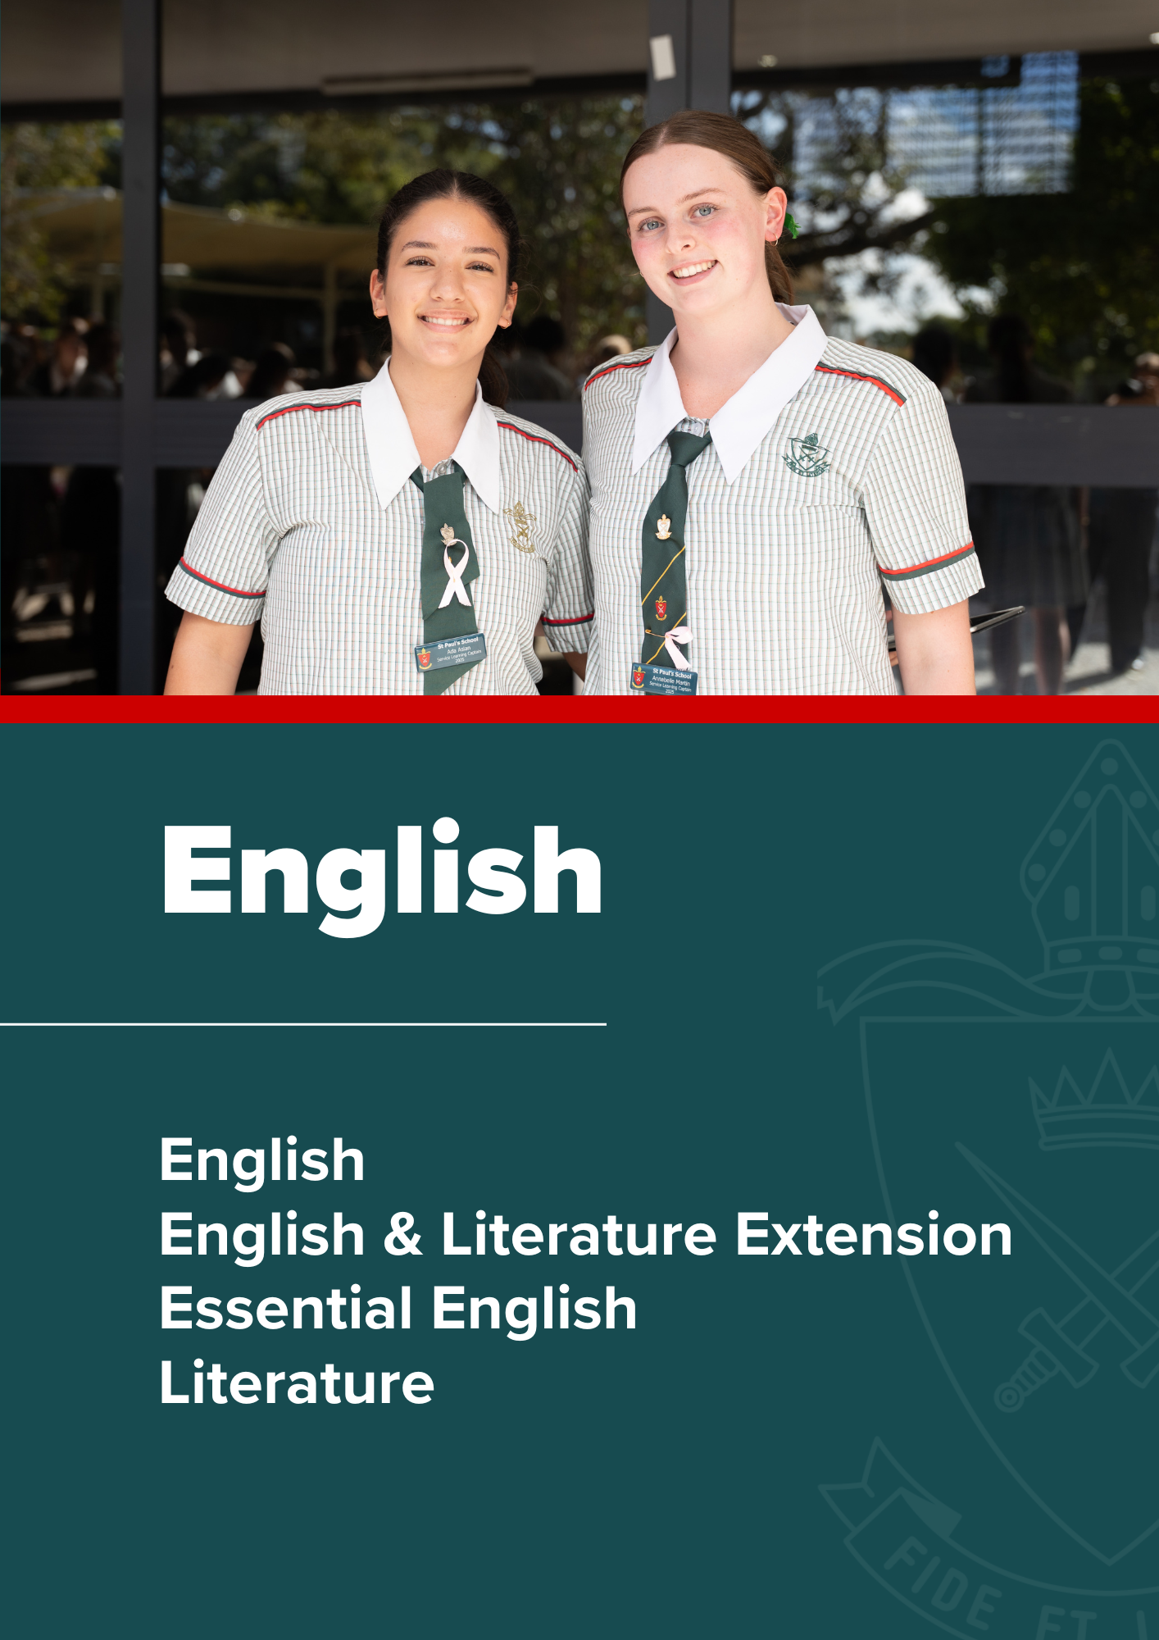

English

English | General Subject

Rationale
English learning area subjects offer students opportunities to enjoy language and be empowered as functional, purposeful, creative and critical language users who understand how texts can convey and transform personal and cultural perspectives. In a world of rapid cultural, social, economic and technological change, complex demands are placed on citizens to be literate within a variety of modes and mediums. Students are offered opportunities to develop this capacity by drawing on a repertoire of resources to interpret and create texts for personal, cultural, social and aesthetic purposes. They learn how language varies according to context, purpose and audience, content, modes and mediums, and how to use it appropriately and effectively for a variety of purposes. Students have opportunities to engage with diverse texts to help them develop a sense of themselves, their world and their place in it.
The subject English focuses on the study of both literary texts and non-literary texts, developing students as independent, innovative and creative learners and thinkers who appreciate the aesthetic use of language, analyse perspectives and evidence, and challenge ideas and interpretations through the analysis and creation of varied texts.
Students have opportunities to engage with language and texts through a range of teaching and learning experiences to foster:
- skills to communicate effectively in Standard Australian English for the purposes of responding to and creating literary and non-literary texts
- skills to make choices about generic structures, language, textual features and technologies for participating actively in literary analysis and the creation of texts in a range of modes, mediums and forms, for a variety of purposes and audiences
- enjoyment and appreciation of literary and non-literary texts, the aesthetic use of language, and style
- creative thinking and imagination, by exploring how literary and non-literary texts shape perceptions of the world and enable us to enter the worlds of others
- critical exploration of ways in which literary and non-literary texts may reflect or challenge social and cultural ways of thinking and influence audiences
- empathy for others and appreciation of different perspectives through studying a range of literary and non-literary texts from diverse cultures and periods, including Australian texts by Aboriginal writers and/or Torres Strait Islander writers.

Pathways
A course of study in English promotes open-mindedness, imagination, critical awareness and intellectual flexibility — skills that prepare students for local and global citizenship, and for lifelong learning across a wide range of contexts.

Objectives
The syllabus objectives outline what students have the opportunity to learn:
- Use patterns and conventions of genres to achieve particular purposes in cultural contexts and social situations.
- Establish and maintain roles of the writer/speaker/designer and relationships with audiences.
- Create and analyse perspectives and representations of concepts, identities, times and places.
- Make use of and analyse the ways cultural assumptions, attitudes, values and beliefs underpin texts and invite audiences to take up positions.
- Use aesthetic features and stylistic devices to achieve purposes and analyse their effects in texts.
- Select and synthesise subject matter to support perspectives.
- Organise and sequence subject matter to achieve particular purposes.
- Use cohesive devices to emphasise ideas and connect parts of texts.
- Make language choices for particular purposes and contexts.
- Use grammar and language structures for particular purposes.
- Use mode-appropriate features to achieve particular purposes

Course Structure
Unit 1 | Unit 2 | Unit 3 | Unit 4
Perspectives and texts  - Texts in contexts  - Language and textual analysis  - Responding to and creating texts | Texts and culture  - Texts in contexts  - Language and textual analysis  - Responding to and creating texts | Textual connections  - Conversations about issues in texts  - Conversations about concepts in texts. | Close study of literary texts  - Creative responses to literary texts  - Critical responses to literary texts

Assessment
Schools devise assessments in Units 1 and 2 to suit their local context.
In Units 3 and 4 students complete four summative assessments. The results from each of the assessments are added together to provide a subject score out of 100. Students will also receive an overall subject result (A–E).
Unit 3 |  | Unit 4
Summative internal assessment 1 (IA1):  - Spoken persuasive response | 25% | Summative internal assessment 3 (IA3):  - Examination — extended response | 25%
Summative internal assessment 2 (IA2):  - Written response for a public audience | 25% | Summative external assessment (EA):  - Examination — extended response | 25%

English & Literature Extension (Year 12 Only) | Extension Subject

Rationale
English & Literature Extension is an extension of both the English (2019) and the Literature (2019) syllabuses and should be read in conjunction with those syllabuses. To study English & Literature Extension, students should have completed Units 1 and 2 of either English or Literature. In Year 12, students undertake Units 3 and 4 of English & Literature Extension concurrently with, or after, Units 3 and 4 of English and/or Units 3 and 4 of Literature. The English & Literature Extension course offers more challenge than other English courses and builds on the literature study students have already undertaken.
By offering students the opportunity to specialise in the theorised study of literature, English & Literature Extension provides students with ways they might understand themselves and the potential that literature has to expand the scope of their experiences. The subject assists students to ask critical questions about cultural assumptions, implicit values and differing world views encountered in an exploration of social, cultural and textual understandings about literary texts and the ways they might be interpreted and valued.
In English & Literature Extension, students apply different theoretical approaches to analyse and evaluate a variety of literary texts and different ways readers might interpret these texts. They synthesise different interpretations and relevant theoretical approaches to produce written and spoken extended analytical and evaluative texts. The nature of the learning in this subject provides opportunities for students to work independently on intellectually challenging tasks.

Pathways
A course of study in English & Literature Extension can establish a basis for further education and employment in a range of fields and can lead to a range of careers in areas where understanding social, cultural and textual influences on ways of viewing the world is a key element, such as law, journalism, media, arts, curating, education, policy and human resources. It also provides a good introduction to the academic disciplines and fields of study that involve the application of methodologies based on theoretical understandings.

Objectives
By the conclusion of the course of study, students will:
- demonstrate understanding of literary texts studied to develop interpretation/s
- demonstrate understanding of different theoretical approaches to exploring meaning in texts
- demonstrate understanding of the relationships among theoretical approaches
- apply different theoretical approaches to literary texts to develop and examine interpretations
- analyse how different genres, structures and textual features of literary texts support different interpretations
- use appropriate patterns and conventions of academic genres and communication, including correct terminology, citation and referencing conventions
- use textual features in extended analytical responses to create desired effects for specific audiences
- evaluate theoretical approaches used to explore different interpretations of literary texts
- evaluate interpretations of literary texts, making explicit the theoretical approaches that underpin them
- synthesise analysis of literary texts, theoretical approaches and interpretations with supporting evidence.

Course Structure
To study English & Literature Extension, students should have completed Units 1 and 2 of either English or Literature. In Year 12, students undertake Units 3 and 4 of English & Literature Extension concurrently with, or after, Units 3 and 4 of English and/or Units 3 and 4 of Literature.
Unit 3 | Unit 4
Ways of reading  - Readings and defences  - Defence of a complex transformation | Exploration and evaluation  - Extended academic research paper  - Theorised exploration of texts

Assessment
In Units 3 and 4 students complete four summative assessments. The results from each of the assessments are added together to provide a subject score out of 100. Students will also receive an overall subject result (A–E).

Unit 3 |  | Unit 4
Summative internal assessment 1 (IA1):  - Reading and defence | 20% | Summative internal assessment 3 (IA3):  - Academic research paper | 35%
Summative internal assessment 2 (IA2):  - Defence of a complex transformation | 20% | Summative external assessment (EA):  - Examination — extended response | 25%

Essential English | Applied Subject

Rationale
The subject Essential English develops and refines students’ understanding of language, literature and literacy to enable them to interact confidently and effectively with others in everyday, community and social contexts. The subject encourages students to recognise language and texts as relevant in their lives now and in the future and enables them to understand, accept or challenge the values and attitudes in these texts.

Students have opportunities to engage with language and texts through a range of teaching and learning experiences to foster:
- skills to communicate confidently and effectively in Standard Australian English in a variety of contemporary contexts and social situations, including every day, social, community, further education and work-related contexts
- skills to choose generic structures, language, language features and technologies to best convey meaning
- skills to read for meaning and purpose, and to use, critique and appreciate a range of contemporary literary and non-literary texts
- effective use of language to produce texts for a variety of purposes and audiences
- creative and imaginative thinking to explore their own world and the worlds of others
- active and critical interaction with a range of texts, and an awareness of how language positions both them and others
- empathy for others and appreciation of different perspectives through a study of a range of texts from diverse cultures, including Australian texts by Aboriginal writers and/or Torres Strait Islander writers
- enjoyment of contemporary literary and non-literary texts, including digital texts.

Pathways
A course of study in Essential English promotes open-mindedness, imagination, critical awareness and intellectual flexibility — skills that prepare students for local and global citizenship, and for lifelong learning across a wide range of contexts.

Objectives
The syllabus objectives outline what students have the opportunity to learn:
- Use patterns and conventions of genres to suit particular purposes and audiences
- Use appropriate roles and relationships with audiences
- Construct and explain representations of identities, places, events and/or concepts
- Make use of and explain opinions and/or ideas in texts, according to purpose
- Explain how language features and text structures shape meaning and invite particular responses
- Select and use subject matter to support perspectives
- Sequence subject matter and use mode-appropriate cohesive devices to construct coherent texts
- Make language choices according to register informed by purpose, audience and context
- Use mode-appropriate language features to achieve particular purposes across modes.

Course Structure
Unit 1 | Unit 2 | Unit 3 | Unit 4
Language that works  - Responding to texts  - Creating texts | Texts and human experiences  - Responding to texts  - Creating texts | Language that influences  - Creating and shaping perspectives on community, local and global issues in texts  - Responding to texts that seek to influence audiences | Representations and popular culture texts  - Responding to popular culture texts  - Creating representations of Australian identifies, places, events and concepts

Assessment
Schools devise assessments in Units 1 and 2 to suit their local context.
In Units 3 and 4 students complete four summative assessments. Schools develop three summative internal assessments, and the common internal assessment (CIA) is developed by the QCAA.
Unit 3 | Unit 4
Summative internal assessment 1 (IA1):  - Spoken response | Summative internal assessment 3 (IA3):  - Multimodal response
Summative internal assessment 2 (IA2):  - Common internal assessment (CIA) | Summative internal assessment (IA4):  - Written response

Literature | General Subject

Rationale
The subject Literature focuses on the study of literary texts, developing students as independent, innovative and creative learners and thinkers who appreciate the aesthetic use of language, analyse perspectives and evidence, and challenge ideas and interpretations through the analysis and creation of varied literary texts.
Students have opportunities to engage with language and texts through a range of teaching and learning experiences to foster:
- skills to communicate effectively in Standard Australian English for the purposes of responding to and creating literary texts
- skills to make choices about generic structures, language, textual features and technologies to participate actively in the dialogue and detail of literary analysis and the creation of imaginative and analytical texts in a range of modes, mediums and forms
- enjoyment and appreciation of literary texts and the aesthetic use of language, and style
- creative thinking and imagination by exploring how literary texts shape perceptions of the world and enable us to enter the worlds of others
- critical exploration of ways in which literary texts may reflect or challenge social and cultural ways of thinking and influence audiences
- empathy for others and appreciation of different perspectives through studying a range of literary texts from diverse cultures and periods, including Australian texts by Aboriginal writers and/or Torres Strait Islander writers.

Pathways
A course of study in Literature promotes open-mindedness, imagination, critical awareness and intellectual flexibility — skills that prepare students for local and global citizenship, and for lifelong learning across a wide range of contexts

Objectives
- The syllabus objectives outline what students have the opportunity to learn:Use patterns and conventions of genres to achieve particular purposes in cultural contexts and social situations.
- Establish and maintain roles of the writer/speaker/designer and relationships with audiences.
- Create and analyse perspectives and representations of concepts, identities, times and places.
- Make use of and analyse the ways cultural assumptions, attitudes, values and beliefs underpin texts and invite audiences to take up positions.
- Use aesthetic features and stylistic devices to achieve purposes and analyse their effects in texts.
- Select and synthesise subject matter to support perspectives.
- Organise and sequence subject matter to achieve particular purposes.
- Use cohesive devices to emphasise ideas and connect parts of texts.
- Make language choices for particular purposes and contexts.
- Use grammar and language structures for particular purposes.
- Use mode-appropriate features to achieve particular purposes.

Course Structure
Unit 1 | Unit 2 | Unit 3 | Unit 4
Introduction to literary studies  - Ways literary texts are received and responded to  - How textual choices affect readers  - Creating analytical and imaginative texts | Intertextuality  - Ways literary texts connect with each other — genre, concepts and contexts  - Ways literary texts connect with each other — style and structure  - Creating analytical and imaginative texts | Literature and identity  - Relationship between language, culture and identity in literary texts  - Power of language to represent ideas, events and people  - Creating analytical and imaginative texts | Independent explorations  - Dynamic nature of literary interpretation  - Close examination of style, structure and subject matter  - Creating analytical and imaginative texts

Assessment
Schools devise assessments in Units 1 and 2 to suit their local context.
In Units 3 and 4 students complete four summative assessments. The results from each of the assessments are added together to provide a subject score out of 100. Students will also receive an overall subject result (A–E).
Unit 3 |  | Unit 4
Summative internal assessment 1 (IA1):  - Examination — extended response | 25% | Summative internal assessment 3 (IA3):  - Imaginative response | 25%
Summative internal assessment 2 (IA2):  - Imaginative response | 25% | Summative external assessment (EA):  - Examination — extended response | 25%

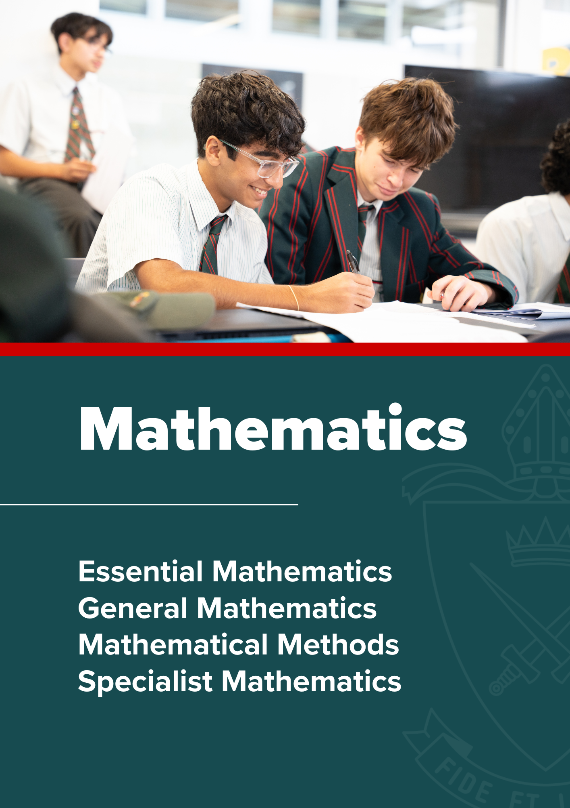

Mathematics

Essential Mathematics | Applied Subject

Rationale
Mathematics is a unique and powerful intellectual discipline that is used to investigate patterns, order, generality and uncertainty. It is a way of thinking in which problems are explored and solved through observation, reflection and logical reasoning. It uses a concise system of communication, with written, symbolic, spoken and visual components. Mathematics is creative, requires initiative and promotes curiosity in an increasingly complex and data-driven world. It is the foundation of all quantitative disciplines.
To prepare students with the knowledge, skills and confidence to participate effectively in the community and the economy requires the development of skills that reflect the demands of the 21st century. Students undertaking Mathematics will develop their critical and creative thinking, oral and written communication, information & communication technologies (ICT) capability, ability to collaborate, and sense of personal and social responsibility — ultimately becoming lifelong learners who demonstrate initiative when facing a challenge. The use of technology to make connections between mathematical theory, practice and application has a positive effect on the development of conceptual understanding and student disposition towards mathematics.
The major domains of mathematics in Essential Mathematics are Number, Data, Location and time, Measurement and Finance. Teaching and learning builds on the proficiency strands of the P–10 Australian Curriculum. Students develop their conceptual understanding when they undertake tasks that require them to connect mathematical concepts, operations and relations. They will learn to recognise definitions, rules and facts from everyday mathematics and data, and to calculate using appropriate mathematical processes.
Students will benefit from studies in Essential Mathematics because they will develop skills that go beyond the traditional ideas of numeracy. This is achieved through a greater emphasis on estimation, problem- solving and reasoning, which develops students into thinking citizens who interpret and use mathematics to make informed predictions and decisions about personal and financial priorities. Students will see mathematics as applicable to their employability and lifestyles, and develop leadership skills through self- direction and productive engagement in their learning. They will show curiosity and imagination and appreciate the benefits of technology. Students will gain an appreciation that there is rarely one way of doing things and that real-world mathematics requires adaptability and flexibility.

Pathways
A course of study in Essential Mathematics can establish a basis for further education and employment in the fields of trade, industry, business and community services. Students learn within a practical context related to general employment and successful participation in society, drawing on the mathematics used by various professional and industry groups.

Objectives
By the conclusion of the course of study, students will:
- recall mathematical knowledge
- use mathematical knowledge
- communicate mathematical knowledge
- evaluate the reasonableness of solutions
- justify procedures and decisions
- solve mathematical problems.

Course Structure
Unit 1 | Unit 2 | Unit 3 | Unit 4
Number, data and graphs  - Fundamental topic: Calculations  - Number  - Representing data  - Managing money | Data and travel  - Fundamental topic: Calculations  - Data collection  - Graphs  - Time and motion | Measurement, scales and chance  - Fundamental topic: Calculations  - Measurement  - Scales, plans and models  - Probability and relative frequencies | Graphs, data and loans  - Fundamental topic: Calculations  - Bivariate graphs  - Summarising and comparing data  - Loans and compound interest

Assessment
Schools devise assessments in Units 1 and 2 to suit their local context.
In Units 3 and 4 students complete four summative assessments. Schools develop three summative internal assessments, and the common internal assessment (CIA) is developed by the QCAA.
Unit 3 | Unit 4
Summative internal assessment 1 (IA1):  - Problem solving and modelling task | Summative internal assessment 3 (IA3):  - Problem solving and modelling task
Summative internal assessment 2 (IA2):  - Common internal assessment-Examination | Summative internal assessment 4 (IA4):  - Examination – short response

Required Equipment
Non-programmable Scientific Calculator, preferred model is the Casio fx-82AU Plus II

General Mathematics | General Subject

Rationale
Mathematics is a unique and powerful intellectual discipline that is used to investigate patterns, order, generality and uncertainty. It is a way of thinking in which problems are explored and solved through observation, reflection and logical reasoning. It uses a concise system of communication, with written, symbolic, spoken and visual components. Mathematics is creative, requires initiative and promotes curiosity in an increasingly complex and data-driven world. It is the foundation of all quantitative disciplines.
To prepare students with the knowledge, skills and confidence to participate effectively in the community and the economy requires the development of skills that reflect the demands of the 21st century. Students undertaking Mathematics will develop their critical and creative thinking, oral and written communication, information & communication technologies (ICT) capability, ability to collaborate, and sense of personal and social responsibility — ultimately becoming lifelong learners who demonstrate initiative when facing a challenge. The use of technology to make connections between mathematical theory, practice and application has a positive effect on the development of conceptual understanding and student disposition towards mathematics.
The major domains of mathematics in General Mathematics are Number and algebra, Measurement and geometry, Statistics and Networks and matrices, building on the content of the P–10 Australian Curriculum. Learning reinforces prior knowledge and further develops key mathematical ideas, including rates and percentages, concepts from financial mathematics, linear and non-linear expressions, sequences, the use of matrices and networks to model and solve authentic problems, the use of trigonometry to find solutions to practical problems, and the exploration of real-world phenomena in statistics.
General Mathematics is designed for students who want to extend their mathematical skills beyond Year 10 but whose future studies or employment pathways do not require calculus. It incorporates a practical approach that equips learners for their needs as future citizens. Students will learn to ask appropriate questions, map out pathways, reason about complex solutions, set up models and communicate in different forms. They will experience the relevance of mathematics to their daily lives, communities and cultural backgrounds. They will develop the ability to understand, analyse and take action regarding social issues in their world. When students gain skill and self-assurance, when they understand the content and when they evaluate their success by using and transferring their knowledge, they develop a mathematical mindset.

Pathways
A course of study in General Mathematics can establish a basis for further education and employment in the fields of business, commerce, education, finance, IT, social science and the arts.

Objectives
By the conclusion of the course of study, students will:
- recall mathematical knowledge
- use mathematical knowledge
- communicate mathematical knowledge
- evaluate the reasonableness of solutions
- justify procedures and decisions
- solve mathematical problems

Course Structure
Unit 1 | Unit 2 | Unit 3 | Unit 4
Money, measurement, algebra and linear equations  - Consumer arithmetic  - Shape and measurement  - Similarity and scale  - Algebra  - Linear equations and their graphs | Applications of linear equations and trigonometry, matrices and univariate data analysis  - Applications of linear equations and their graphs  - Applications of Trigonometry  - Matrices  - Univariate data analysis 1  - Univariate data analysis 2 | Bivariate data and time series analysis, sequences and Earth geometry  - Bivariate data analysis 1  - Bivariate data analysis 2  - Time series analysis  - Growth and decay in sequences  - Earth geometry and time zones | Investing and networking  - Loans, investments and annuities 1  - Loans, investments and annuities 2  - Graphs and networks  - Networks and decision mathematics 1  - Networks and decision mathematics 2

Assessment
Schools devise assessments in Units 1 and 2 to suit their local context.
In Units 3 and 4 students complete four summative assessments. The results from each of the assessments are added together to provide a subject score out of 100. Students will also receive an overall subject result (A–E).
Unit 3 |  | Unit 4
Summative internal assessment 1 (IA1): 20% Problem-solving and modelling task
Summative internal assessment 2 (IA2):  - Examination — short response | 15% | Summative internal assessment 3 (IA3):  - Examination — short response | 15%
Summative external assessment (EA): 50%
- Examination — combination response

Required Equipment
Non-programmable Scientific Calculator, preferred model is the Casio fx-82AU Plus II

Mathematical Methods | General Subject

Rationale
Mathematics is a unique and powerful intellectual discipline that is used to investigate patterns, order, generality and uncertainty. It is a way of thinking in which problems are explored and solved through observation, reflection and logical reasoning. It uses a concise system of communication, with written, symbolic, spoken and visual components. Mathematics is creative, requires initiative and promotes curiosity in an increasingly complex and data-driven world. It is the foundation of all quantitative disciplines.
To prepare students with the knowledge, skills and confidence to participate effectively in the community and the economy requires the development of skills that reflect the demands of the 21st century. Students undertaking Mathematics will develop their critical and creative thinking, oral and written communication, information & communication technologies (ICT) capability, ability to collaborate, and sense of personal and social responsibility — ultimately becoming lifelong learners who demonstrate initiative when facing a challenge. The use of technology to make connections between mathematical theory, practice and application has a positive effect on the development of conceptual understanding and student disposition towards mathematics.
The major domains of mathematics in Mathematical Methods are Algebra, Functions, relations and their graphs, Calculus and Statistics. Topics are developed systematically, with increasing levels of sophistication, complexity and connection, and build on algebra, functions and their graphs, and probability from the P–10 Australian Curriculum. Calculus is essential for developing an understanding of the physical world. The domain Statistics is used to describe and analyse phenomena involving uncertainty and variation. Both are the basis for developing effective models of the world and solving complex and abstract mathematical problems. The ability to translate written, numerical, algebraic, symbolic and graphical information from one representation to another is a vital part of learning in Mathematical Methods.
Students who undertake Mathematical Methods will see the connections between mathematics and other areas of the curriculum and apply their mathematical skills to real-world problems, becoming critical thinkers, innovators and problem-solvers. Through solving problems and developing models, they will appreciate that mathematics and statistics are dynamic tools that are critically important in the 21st century.

Pathways
A course of study in Mathematical Methods can establish a basis for further education and employment in the fields of natural and physical sciences (especially physics and chemistry), mathematics and science education, medical and health sciences (including human biology, biomedical science, nanoscience and forensics), engineering (including chemical, civil, electrical and mechanical engineering, avionics, communications and mining), computer science (including electronics and software design), psychology and business.

Objectives
By the conclusion of the course of study, students will:
- recall mathematical knowledge
- use mathematical knowledge
- communicate mathematical knowledge
- evaluate the reasonableness of solutions
- justify procedures and decisions
- solve mathematical problems.

Course Structure
Unit 1 | Unit 2 | Unit 3 | Unit 4
Surds, algebra, functions and probability  - Surds and quadratic functions  - Binomial expansion and cubic functions  - Functions and relations  - Trigonometric functions  - Probability | Calculus and further functions  - Exponential functions  - Logarithms and logarithmic functions  - Introduction to differential calculus  - Applications of differential calculus  - Further differentiation | Further calculus and introduction to statistics  - Differentiation of exponential and logarithmic functions  - Differentiation of trigonometric functions and differentiation rules  - Further applications of differentiation  - Introduction to integration  - Discrete random variables | Further calculus, trigonometry and statistics  - Further integration  - Trigonometry  - Continuous random variables and the normal distribution  - Sampling and proportions  - Interval estimates for proportions

Assessment
Schools devise assessments in Units 1 and 2 to suit their local context.
In Units 3 and 4 students complete four summative assessments. The results from each of the assessments are added together to provide a subject score out of 100. Students will also receive an overall subject result (A–E).
Unit 3 |  | Unit 4
Summative internal assessment 1 (IA1): 20% Problem-solving and modelling task
Summative internal assessment 2 (IA2):  - Examination — short response | 15% | Summative internal assessment 3 (IA3):  - Examination — short response | 15%
Summative external assessment (EA): 50%
- Examination — combination response

Required Equipment
Non-programmable Graphics Calculator, preferred model is the Casio fxCG-50AU

Specialist Mathematics | General Subject

Rationale
Mathematics is a unique and powerful intellectual discipline that is used to investigate patterns, order, generality and uncertainty. It is a way of thinking in which problems are explored and solved through observation, reflection and logical reasoning. It uses a concise system of communication, with written, symbolic, spoken and visual components. Mathematics is creative, requires initiative and promotes curiosity in an increasingly complex and data-driven world. It is the foundation of all quantitative disciplines.
To prepare students with the knowledge, skills and confidence to participate effectively in the community and the economy requires the development of skills that reflect the demands of the 21st century. Students undertaking Mathematics will develop their critical and creative thinking, oral and written communication, information & communication technologies (ICT) capability, ability to collaborate, and sense of personal and social responsibility — ultimately becoming lifelong learners who demonstrate initiative when facing a challenge. The use of technology to make connections between mathematical theory, practice and application has a positive effect on the development of conceptual understanding and student disposition towards mathematics.
The major domains of mathematical knowledge in Specialist Mathematics are Vectors and matrices, Real and complex numbers, Trigonometry, Statistics and Calculus. Topics are developed systematically, with increasing levels of sophistication, complexity and connection, building on functions, calculus, statistics from Mathematical Methods, while vectors, complex numbers and matrices are introduced. Functions and calculus are essential for creating models of the physical world. Statistics are used to describe and analyse phenomena involving probability, uncertainty and variation. Matrices, complex numbers and vectors are essential tools for explaining abstract or complex relationships that occur in scientific and technological endeavours.
Students who undertake Specialist Mathematics will develop confidence in their mathematical knowledge and ability and gain a positive view of themselves as mathematics learners. They will gain an appreciation of the true nature of mathematics, its beauty and its power.

Pathways
A course of study in Specialist Mathematics can establish a basis for further education and employment in the fields of science, all branches of mathematics and statistics, computer science, medicine, engineering, finance and economics.

Course Requirement
Specialist Mathematics is designed to be taken in conjunction with, or on completion of, Mathematical Methods.

Objectives
By the conclusion of the course of study, students will:
- recall mathematical knowledge
- use mathematical knowledge
- communicate mathematical knowledge
- evaluate the reasonableness of solutions
- justify procedures and decisions
- solve mathematical problems

Course Structure
Specialist Mathematics is to be undertaken in conjunction with, or on completion of, Mathematical Methods.
Unit 1 | Unit 2 | Unit 3 | Unit 4
Combinatorics, proof, vectors and matrices  - Combinatorics  - Introduction to proof  - Vectors in the plane  - Algebra of vectors in two dimensions  - Matrices | Complex numbers, further proof, trigonometry, functions and transformations  - Complex numbers  - Complex arithmetic and algebra  - Circle and geometric proofs  - Trigonometry and functions  - Matrices and transformations | Further complex numbers, proof, vectors and matrices  - Further complex numbers  - Mathematical induction and trigonometric proofs  - Vectors in two and three dimensions  - Vector calculus  - Further matrices | Further calculus and statistical inference  - Integration techniques  - Applications of integral calculus  - Rates of change and differential equations  - Modelling motion  - Statistical inference

Assessment
Schools devise assessments in Units 1 and 2 to suit their local context.
In Units 3 and 4 students complete four summative assessments. The results from each of the assessments are added together to provide a subject score out of 100. Students will also receive an overall subject result (A–E).
Unit 3 |  | Unit 4
Summative internal assessment 1 (IA1):  - Problem-solving and modelling task | 20% | Summative internal assessment 3 (IA3):  - Examination — short response | 15%
Summative internal assessment 2 (IA2):  - Examination — short response | 15%
Summative external assessment (EA): 50%
- Examination — combination response

Required Equipment
Non-programmable Graphics Calculator, preferred model is the Casio fxCG-50AU

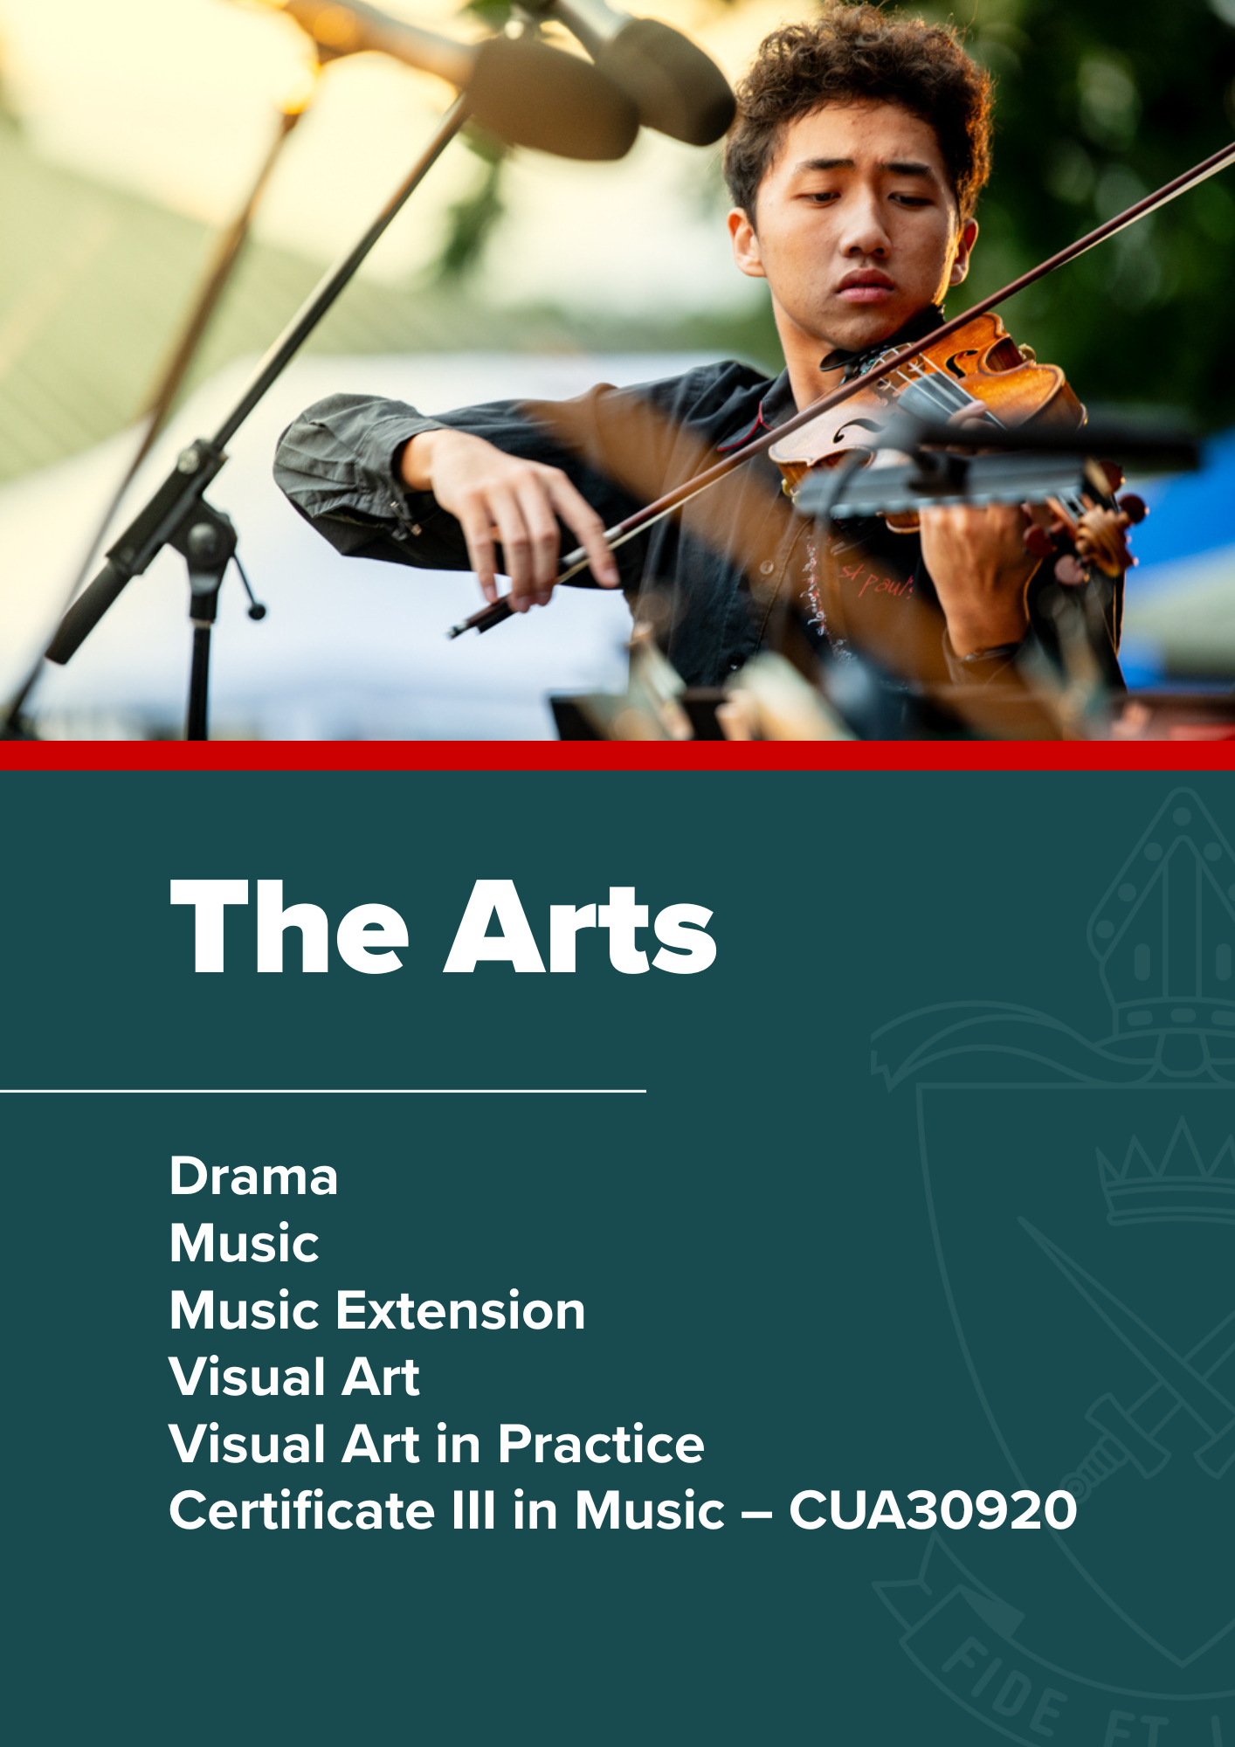

The Arts

Drama | General Subject

Rationale
Drama interrogates the human experience by investigating, communicating and embodying stories, experiences, emotions and ideas that reflect the human experience. It allows students to look to the past with curiosity and explore inherited traditions of artistry to inform their own artistic practice and shape their world as global citizens. Drama is created and performed in diverse spaces, including formal and informal theatre spaces, to achieve a wide range of purposes. Drama engages students in imaginative meaning-making processes and involves them using a range of artistic skills as they make and respond to dramatic works. The range of purposes, contexts and audiences provides students with opportunities to experience, reflect on, understand, communicate, collaborate and appreciate different perspectives of themselves, others and the world in which they live.
Across the course of study, students will develop a range of interrelated skills of drama that will complement the knowledge and processes needed to create dramatic action and meaning. They will learn about the dramatic languages and how these contribute to the creation, interpretation and critique of dramatic action and meaning for a range of purposes. A study of a range of forms and styles in a variety of inherited traditions, current practice and emerging trends, including those from different cultures and contexts, forms a core aspect of the learning. Drama provides opportunities for students to learn how to engage with dramatic works as both artists and audience through the use of critical literacies.
In Drama, students engage in aesthetic learning experiences that develop the 21st century skills of critical thinking, creative thinking, communication, collaboration and teamwork, personal and social skills, and digital literacy. They learn how to reflect on their artistic, intellectual, emotional and kinaesthetic understanding as creative and critical thinkers and curious artists. Additionally, students will develop personal confidence, skills of inquiry and social skills as they work collaboratively with others.
Drama engages students in the making of and responding to dramatic works to help them realise their creative potential as individuals. Learning in Drama promotes a deeper and more empathetic understanding and appreciation of others and communities. Innovation and creative thinking are at the forefront of this subject, which contributes to equipping students with highly transferable skills that encourage them to imagine future perspectives and possibilities.

Pathways
A course of study in Drama can establish a basis for further education and employment in the field of drama, and to broader areas in creative industries, cultural institutions, administration and management, law, communications, education, public relations, research, science and technology. The understanding and skills built in Drama connect strongly with careers in which it is important to understand different social and cultural perspectives in a range of contexts, and to communicate meaning in functional and imaginative ways.

Objectives
By the conclusion of the course of study, students will:
- demonstrate skills of drama
- apply literacy skills
- interpret purpose, context and text
- manipulate dramatic languages
- analyse dramatic languages
- evaluate dramatic languages.

Course Structure
Unit 1 | Unit 2 | Unit 3 | Unit 4
Share  How does drama promote shared understandings of the human experience? | Reflect  How is drama shaped to reflect lived experience? | Challenge  How can we use drama to challenge our understanding of humanity? | Transform  How can you transform dramatic practice?

Assessment
Schools devise assessments in Units 1 and 2 to suit their local context.
In Units 3 and 4 students complete four summative assessments. The results from each of the assessments are added together to provide a subject score out of 100. Students will also receive an overall subject result (A-E).
Unit 3 |  | Unit 4
Summative internal assessment 1 (IA1):  - Performance | 20% | Summative internal assessment 3 (IA3):  - Practice-led project | 35%
Summative internal assessment 2 (IA2):  - Dramatic concept | 20%
Summative external assessment (EA): 25%
- Examination — extended response

Music | General Subject

Rationale
Music is a unique art form that uses sound and silence as a means of personal expression. It allows for the expression of the intellect, imagination and emotion and the exploration of values. Music occupies a significant place in everyday life of all cultures and societies, serving social, cultural, celebratory, political and educational roles.
The study of music combines the development of cognitive, psychomotor, and affective domains through making and responding to music. The development of musicianship through making (composition and performance) and responding (musicology) is at the centre of the study of music.
Through composition, students use music elements and concepts, applying their knowledge and understanding of compositional devices to create new music works. Students resolve music ideas to convey meaning and/or emotion to an audience.
Through performance, students sing and play music, demonstrating their practical music skills through refining solo and/or ensemble performances. Students realise music ideas through the demonstration and interpretation of music elements and concepts to convey meaning and/or emotion to an audience.
In musicology, students explain music elements and concepts, analysing music in a variety of contexts, styles and genres. They evaluate music through the synthesis of analytical information to justify a viewpoint.
In an age of change, Music has the means to prepare students for a future of unimagined possibilities. In Music, students develop highly transferable skills and the capacity for flexible thinking and doing. Literacy in Music is an essential skill for both musician and audience, and learning in Music prepares students to engage in a multimodal world. The study of Music provides students with opportunities for intellectual and personal growth, and to make a contribution to the culture of their community. Students develop the capacity for working independently and collaboratively, reflecting authentic practices of music performers, composers and audiences.

Pathways
A course of study in Music can establish a basis for further education and employment in the field of music, and more broadly, in creative industries, cultural institutions, administration and management, health, communications, education, public relations, research, science and technology. As more organisations value work-related creativity and diversity, the processes and practices of Music develop 21st century skills essential for many areas of employment. Specifically, the study of Music helps students develop creative and critical thinking, collaboration and communication skills, personal and social skills, and digital literacy — all of which are sought after in modern workplaces.

Objectives
By the conclusion of the course of study, students will:
- demonstrate technical skills
- use music elements and concepts
- analyse music
- apply compositional devices
- apply literacy skills
- interpret music elements and concepts
- evaluate music
- realise music ideas
- resolve music ideas.

Course structure
Unit 1 | Unit 2 | Unit 3 | Unit 4
Designs  Through inquiry learning, the following is explored:  How does the treatment and combination of different music elements enable musicians to design music that communicates meaning through performance and composition? | Identities  Through inquiry learning, the following is explored:  How do musicians use their understanding of music elements, concepts, and practices to communicate cultural, political, social and personal identities when performing, composing and responding to music? | Innovations  Through inquiry learning, the following is explored:  How do musicians incorporate innovative music practices to communicate meaning when performing and composing? | Narratives  Through inquiry learning, the following is explored:  How do musicians manipulate music elements to communicate narrative when performing, composing and responding to music?

Assessment
Schools devise assessments in Units 1 and 2 to suit their local context.
In Units 3 and 4 students complete four summative assessments. The results from each of the assessments are added together to provide a subject score out of 100. Students will also receive an overall subject result (A-E).
Unit 3 |  | Unit 4
Summative internal assessment 1 (IA1):  - Performance | 20% | Summative internal assessment 3 (IA3):  - Project | 35%
Summative internal assessment 2 (IA2):  - Composition | 20%
Summative external assessment (EA): 25%
- Examination — extended response

Required Equipment
Headphones that fit student laptops (generally 3.5mm plug).

Music Extension (Year 12 Only) | Extension Subject

Rationale
The Music Extension syllabus should be read in conjunction with the Music syllabus. In Music Extension, students follow an individual program of study designed to continue the development of refined musicianship skills. Music Extension encourages students to investigate music concepts and ideas relevant to their specialisation.
In the Composition specialisation (making), students create and resolve new music works. They demonstrate use of music concepts and manipulate music concepts to express meaning and/or emotion to an audience through resolved compositions.
In the Musicology specialisation (responding), students investigate and analyse music works and ideas. They synthesise analytical information about music, and document sources and references about music to support research.
In the Performance specialisation (making), students realise music works, demonstrating technical skills and understanding. They make decisions about music, interpret music elements and concepts, and realise music ideas in their performances.
Music Extension prepares students for a future of unimagined possibilities, helping them to become self- motivated and emotionally aware. As a unique means of expression, music makes a profound contribution to personal, social and cultural identities. Students develop transferable skills, becoming adaptable and innovative problem-solvers and collaborative team members who make informed decisions. As enquirers, students develop their ability to analyse and critically evaluate. Literacy in Music Extension is an essential skill for composers, musicologists and performers, and learning in Music Extension prepares students to engage in a multimodal world.

Pathways
A course of study in Music Extension can establish a basis for further education and employment in the field of music, and more broadly, in creative industries, cultural institutions, administration and management, health, communications, education, public relations, research, science and technology.

Objectives

Common objectives
By the conclusion of the course of study, all students will:
- analyse music
- apply literacy skills
- evaluate music.

Specialist objectives
By the conclusion of the course of study, in addition to the common objectives, students who specialise in composition will also:
- apply compositional devices
- manipulate music elements and concepts
- resolve music ideas.

By the conclusion of the course of study, in addition to the common objectives, students who specialise in
musicology will also:

- express meaning or ideas about music
- investigate music and ideas about music
- synthesis information.

By the conclusion of the course of study, in addition to the common objectives, students who specialise in
performance will also:

- apply technical skills
- interpret music elements and concepts
- realise music ideas.

Course Structure
Unit 3 | Unit 4
Explore  - Key idea 1: Initiate best practice  - Key idea 2: Consolidate best practice | Emerge  - Key idea 3: Independent best practice

Assessment
In Units 3 and 4 students complete four summative assessments. The results from each of the assessments are added together to provide a subject score out of 100. Students will also receive an overall subject result (A–E).

Note: The Summative external assessment (EA): Examination — extended response is the same assessment for all three specialisations.

Composition specialisation
Unit 3 |  | Unit 4
Summative internal assessment 1 (IA1):  - Composition 1 | 20% | Summative internal assessment 3 (IA3):  - Composition project | 35%
Summative internal assessment 2 (IA2):  - Composition 2 | 20%
Summative external assessment (EA): 25%
- Examination — extended response

Musicology specialisation
Unit 3 |  | Unit 4
Summative internal assessment 1 (IA1):  - Investigation 1 | 20% | Summative internal assessment 3 (IA3):  - Musicology project | 35%
Summative internal assessment 2 (IA2):  - Investigation 2 | 20%
Summative external assessment (EA): 25%
- Examination — extended response

Performance specialisation
Unit 3 |  | Unit 4
Summative internal assessment 1 (IA1):  - Performance 1 | 20% | Summative internal assessment 3 (IA3):  - Performance project | 35%
Summative internal assessment 2 (IA2):  - Performance 2 | 20%
Summative external assessment (EA): 25%
- Examination — extended response

Visual Art | General Subject

Rationale
Visual Art students have opportunities to construct knowledge and communicate personal interpretations by working as both artist and audience. In making artworks, students use their imagination and creativity to innovatively solve problems and experiment with visual language and expression. Students develop knowledge and skills when they create individualised responses and meaning by applying diverse art materials, techniques, technologies and processes. On their individual journey of exploration, students learn to communicate personal thoughts, feelings, ideas, experiences and observations. In responding to artworks, students investigate artistic expression and critically analyse artworks in diverse contexts. They consider meaning, purposes and theoretical approaches when ascribing aesthetic value and challenging ideas. Students interact with artists, artworks, institutions and communities to enrich their experiences and understandings of their own and others’ art practices.
Visual Art uses an inquiry learning model, developing critical and creative thinking skills and individual responses through developing, researching, reflecting and resolving. Through making and responding, resolution and display of artworks, students understand and appreciate the role of visual art in past and present traditions and cultures, as well as the contributions of contemporary visual artists and their aesthetic, historical and cultural influences.

Pathways
This subject prepares young people for participation in the 21st century by fostering curiosity and imagination, and teaching students how to generate and apply new and creative solutions when problem- solving in a range of contexts. This learnt ability to think in divergent ways and produce creative and expressive responses enables future artists, designers and craftspeople to innovate and collaborate with the fields of science, technology, engineering and mathematics to design and manufacture images and objects that enhance and contribute significantly to our daily lives.
Visual Art prepares students to engage in a multimodal, media-saturated world that is reliant on visual communication. Through the critical thinking and literacy skills essential to both artist and audience, learning in Visual Art empowers young people to be discriminating, and to engage with and make sense of what they see and experience.
A course of study in Visual Art can establish a basis for further education and employment in the fields of arts practice, design, craft, and information technologies, and more broadly, in creative industries, cultural institutions, advertising, administration and management, communication, education, public relations, health, research, science and technology.

Objectives
By the conclusion of the course of study, students will:
- implement ideas and representations
- apply literacy skills
- analyse and interpret visual language, expression and meaning in artworks and practices
- evaluate influences
- justify viewpoints
- experiment in response to stimulus
- create visual responses using knowledge and understanding of art media
- realise responses to communicate meaning

Course Structure
Unit 1 | Unit 2 | Unit 3 | Unit 4
Art as lens  - Concept: lenses to explore the material world  - Contexts: personal and contemporary  - Focus: people, place, objects | Art as code  - Concept: art as a coded visual language  - Contexts: formal and cultural  - Focus: codes, symbols, signs and art conventions | Art as knowledge  - Concept: constructing knowledge as artist and audience  - Contexts: contemporary, personal, cultural and/or formal  - Focus: student- directed | Art as alternate  - Concept: evolving alternate representations and meaning  - Contexts: contemporary, personal, cultural and/or formal  - Focus: student- directed

Assessment
Schools devise assessments in Units 1 and 2 to suit their local context.
In Units 3 and 4 students complete four summative assessments. The results from each of the assessments are added together to provide a subject score out of 100. Students will also receive an overall subject result (A–E).
Unit 3 |  | Unit 4
Summative internal assessment 1 (IA1):  - Investigation — inquiry phase 1 | 20% | Summative internal assessment 3 (IA3):  - Project — inquiry phase 3 | 30%
Summative internal assessment 2 (IA2):  - Project — inquiry phase 2 | 25%
Summative external assessment (EA): 25%
- Examination — extended response

Visual Art in Practice| Applied Subject

Rationale
The arts are woven into the fabric of community. They have the capacity to engage and inspire students, enriching their lives, stimulating curiosity and imagination, and encouraging them to reach their creative and expressive potential. Arts subjects provide opportunities for students to learn problem-solving processes, design and create art, and use multiple literacies to communicate intention with diverse audiences.
In Visual Art in Practice, students respond to authentic, real-world stimulus (e.g. problems, events, stories, places, objects, the work of artists or artisans), seeing or making new links between art-making purposes and contexts. They explore visual language in combination with media, technologies and skills to make artworks. Throughout the course, students are exposed to two or more art-making modes, selecting from 2D, 3D, digital (static) and time-based and using these in isolation or combination, as well as innovating new ways of working.
When responding, students use analytical processes to identify problems and develop plans or designs for artworks. They use reasoning and decision-making to justify their choices, reflecting and evaluating on the success of their own and others’ art-making. When making, students demonstrate knowledge and understanding of visual features to communicate artistic intention. They develop competency with and independent selection of media, technologies and skills as they make experimental and resolved artworks, synthesising ideas developed throughout the responding phase.

Pathways
Learning in Visual Art in Practice is connected to relevant industry practice and opportunities, promoting future employment and preparing students as agile, competent, innovative and safe workers who can work collaboratively to solve problems and complete project-based work in various contexts.
A course of study in Visual Art in Practice can establish a basis for further education and employment in a range of fields, including creative industries, education, advertising and marketing, communications, humanities, health, recreation, science and technology.

Objectives
By the conclusion of the course of study, students should:
- use visual arts practices
- plan artworks
- communicate ideas
- evaluate artworks.

Course Structure
Visual Art in Practice is a four-unit course of study. This syllabus contains four QCAA-developed units as options for schools to combine in any order to develop their course of study.

Unit option | Unit title | Unit option | Unit title
Unit option A | Looking inwards (self) | Unit option C | Clients
Unit option B | Looking outwards (others) | Unit option D | Transform & extend

Assessment
Students complete two assessment tasks for each unit. The assessment techniques used in Visual Art in Practice are:

Technique | Description | Response requirements
Project | Students make experimental or prototype artworks, or design proposals or stylistic experiments. They evaluate artworks, art style and/or practices that explore the focus of the unit. Students plan resolved artworks. | Experimental folio  Up to 8 experimental artworks: 2D, 3D, digital (static) and/or time-based  OR  Prototype artwork  2D, 3D, digital (static) and/or time-based media: up to 4 artwork/s  OR  Design proposal  Multimodal (at least two modes delivered at the same time): up to 5 minutes, 8 A4 pages, or equivalent digital media, including up to 4 prototype artwork/s — 2D, 3D, digital (static) and/or time-based  OR  Folio of stylistic experiments  Up to 8 experimental artworks: 2D, 3D, digital (static) and/or time-based  AND  Planning and evaluations  One of the following:  Multimodal (at least two modes delivered at the same time): up to 5 minutes, 8 A4 pages, or equivalent digital media  Written: up to 600 words  Spoken: up to 4 minutes, or signed equivalent
Resolved artwork | Students make a resolved artwork that communicates purpose and context relating to the focus of the unit. | Resolved artwork  2D, 3D, digital (static) and/or time-based media: up to 4 artwork/s

Cert III in Music – CUA30920 | VET Subject

Rationale
This is a stand-alone VET subject, studied over a 2-year period, commencing in Year 11. Upon successful completion, a nationally-accredited Certificate III will be awarded by an external Registered Training Organisation (RTO) or a Statement of Attainment will be issued if only partial completion of the course is achieved.

For whom is the course intended?
The Certificate III in Music prepares students for entry into a range of music related courses and with the necessary minimum qualifications to work directly in this field if so desired. Graduates would be able to seek mutual recognition in other courses incorporating the same or equivalent units or competence. The course is for any student with an interest in all forms of music technology including electronic music, sound mixing, recording studios, computer music, midi and music recording in film and television and other media applications.
This certificate may contribute to the calculation of a student’s ATAR.

This qualification will attract 7 credit points towards a student’s Queensland Certificate of Education on full completion of the qualification.

What will I study in the course?
- Analogue and Digital audio engineering, focusing on recording techniques and operation of Digital Audio Workstations.
- Sound editing techniques.
- Effective use of Logic Pro recording software in the music studio and other associated music software.
- Managing live audio projects.
- Health, Safety and Security measures in the Music Industry.
- How to use MIDI devices and/or software to perform music.
- How to manage your own work and learning.

What sort of skills will I need to cope with the course?
- A broad understanding of Multi-Media applications.
- Independent motivation and the ability to work under self direction.
- Basic foundations in Music Theory, equating to a pass in Year 9 Music or equivalent.
- An interest in Music and Sound Technology.
- Willingness to participate in extracurricular events.
- An ability to play and read music can useful, but not essential.

Course Structure
As a guide, the following Core Units will be studied in this qualification. These units are mandatory:
CUAID314 | Plan a career in the creative arts industry
CUANIND313 | Work effectively in the music industry
CCUANIND311 | Implement copyright arrangements

The following elective units have been selected to provide specialist training in sound engineering:
CUASOU412 | Manage audio input sources
CUASOU321 | Mix music in studio environments
CUASOU317 | Record and mix basic music demos
CUASOU306 | Operate sound reinforcement systems
CUASOU212 | Perform basic sound editing
CUAMCP211 | Incorporate technology into music making
CUALGT311 | Operate basic lighting

Assessment
This is a competency-based course. This means that students work to develop the competencies, skills and knowledge described in each Unit of Competency. To be assessed as competent, a student must demonstrate to a qualified assessor that they can effectively carry out the various tasks and combinations of tasks listed to the standard required in the appropriate industry. There is no level awarded in competency- based assessment. Students are assessed as either 'competent' or 'not yet competent'. Students will be progressively assessed in individual Units of Competency. When a student achieves a Unit of Competency it is signed off by the assessor on a Student Profile Sheet.
Assessment of the units of competency/modules is competency-based and must be conducted in accordance with the national assessment principles. Competency-based assessment is the process of collecting evidence and making judgments on whether or not a student can consistently demonstrate knowledge and skill, and the application of that knowledge and skill to the standard of performance required in the workplace. Elements of competency do not have to be assessed individually. Holistic assessment techniques can be used, and integrated assessment is encouraged. Where the nature of the competency is such that it is not possible to assess it using demonstration/observation, forms of assessment such as simulations, tests, work-based projects or assignments may be utilised.

Assessment methods encompass a range of techniques, which include, but are not limited to, the use of: direct observation of performance, simulations of workplace activities, oral questioning, practical exercises, projects/assignment, work portfolios etc.

Possible Pathways and Applications
This course articulates in the following Certificate courses:
- Certificate IV in Music
- Certificate IV in Sound Production
- Certificate IV in Music Business
- Diploma of Sound Production
- Diploma of Music Business
- Advanced Diploma of Music Business
- Advanced Diploma of Sound Production
- Bachelor Degrees in Music Technology (Griffith Conservatorium) – Portfolio & Interview
- Bachelor of Fine Arts – Sound Design (QUT) - Portfolio & Interview.

Required Equipment
Headphones that fit student laptops (generally 3.5mm plug).

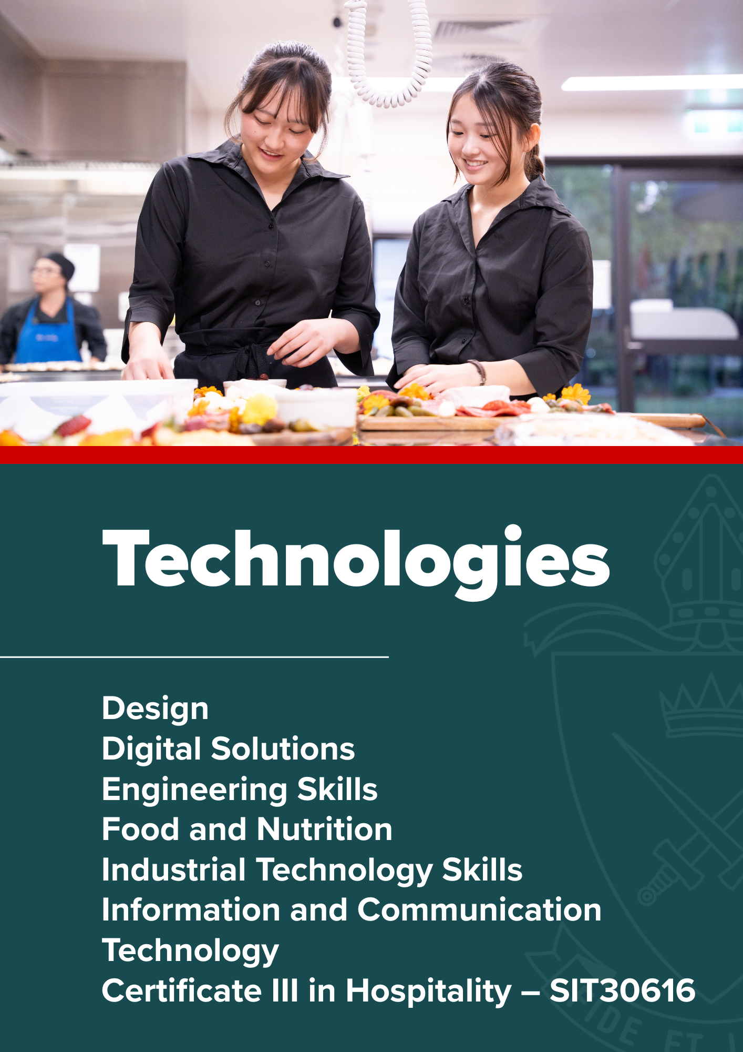

Technologies

Design | General Subject

Rationale
The Design subject focuses on the application of design thinking to envisage creative products, services and environments in response to human needs, wants and opportunities. Designing is a complex and sophisticated form of problem-solving that uses divergent and convergent thinking strategies that can be practised and improved. Designers are separated from the constraints of production processes to allow them to appreciate and exploit new innovative ideas.
In Unit 1, students will learn about and experience designing in the context of stakeholder-centred design. They will be introduced to the range and importance of stakeholders and how the design process is used to respond to their needs and wants. In Unit 2, students will learn about and experience designing in the context of commercial design, considering the role of the client and the influence of economic, social and cultural issues. They will use a collaborative design approach. In Unit 3, students will learn about and experience designing in the context of human-centred design. They will use designing with empathy as an approach as they respond to the needs and wants of a particular person. In Unit 4, students will learn about and experience designing in the context of sustainable design. They will explore design opportunities and design to improve economic, social and ecological sustainability.

The teaching and learning approach uses a design process grounded in the problem-based learning framework. This approach enables students to learn about and experience design through exploring needs, wants and opportunities; developing ideas and design concepts; using sketching and low-fidelity prototyping skills; and evaluating ideas. Students communicate design proposals to suit different audiences.
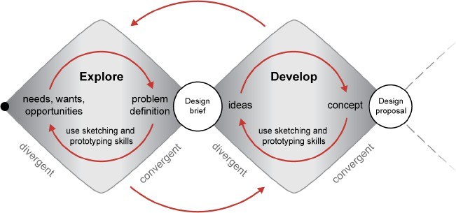
Students will learn how design has influenced the economic, social and cultural environment in which they live. They will understand the agency of humans in conceiving and imagining possible futures through design. Students will develop valuable 21st century skills in critical thinking, creative thinking, communication, collaboration and teamwork, personal and social skills, and information & communication technologies (ICT) skills. Collaboration, teamwork and communication are crucial skills needed to work in design teams and liaise with stakeholders. The design thinking students learn is broadly applicable to a range of professions and supports the development of critical and creative thinking.

Students will develop an appreciation of designers and their role in society. They will learn the value of creativity and build resilience as they experience iterative design processes, where the best ideas may be the result of trial and error and a willingness to take risks and experiment with alternatives. Design equips students with highly transferrable, future focused thinking skills relevant to a global context.

Pathways
Design is a general subject suited to students who are interested in pathways beyond school that lead to tertiary studies, vocational education or work. A course of study in Design can establish a basis for further education and employment in the fields of architecture, digital media design, application (app) design, website design, fashion design, graphic design, industrial design, interior design and landscape architecture.

Course Structure
Unit 1 | Unit 2 | Unit 3 | Unit 4
Stakeholder-centred design  - Topic 1: Designing for others | Commercial design influences  - Topic 1: Responding to needs and wants | Human-centred design  - Topic 1: Designing with empathy | Sustainable design influences  - Topic 1: Responding to opportunities

Assessment
Students should have opportunities in Units 1 and 2 to experience and respond to the types of assessment they will encounter in Units 3 and 4.
Unit 3 |  | Unit 4
Summative internal assessment 1 (IA1)  - Examination – design challenge | 20% | Summative internal assessment 3 (IA3)  - Project | 25%
Summative internal assessment 2 (IA2)  - Project | 30% | Summative external assessment (EA)  - Examination – design challenge | 25%

Digital Solutions | General Subject

Rationale
Technologies have been an integral part of society for as long as humans have had the desire to create solutions to improve their own and others’ quality of life. Technologies have an impact on people and societies by transforming, restoring and sustaining the world in which we live.

Australia needs enterprising and innovative individuals with the ability to make discerning decisions concerning the development, use and impact of technologies. When developing technologies, these individuals need to be able to work independently and collaboratively to solve open-ended problems. Digital Solutions prepares students to be effective problem-solvers as they learn about and work with contemporary and emerging technologies.

In Digital Solutions, students learn about algorithms, computer languages and user interfaces through generating digital solutions to problems. They engage with data, information and applications to create digital solutions that filter and present data in timely and efficient ways while understanding the need to encrypt and protect data. They analyse computing’s personal, local and global impact, and the issues associated with the ethical integration of technology into our daily lives.
Students engage in problem-based learning that enables them to explore and develop ideas, generate digital solutions, and evaluate impacts, components and solutions. They understand that solutions enhance their world and benefit society. To generate digital solutions, students analyse problems and apply computational, design and systems thinking processes. Students understand that progress in the development of digital solutions is driven by people and their needs.

Learning in Digital Solutions provides students with opportunities to develop, generate and repurpose solutions that are relevant in a world where data and digital realms are transforming entertainment, education, business, manufacturing and many other industries. Australia’s workforce and economy requires people who are able to collaborate, use creativity to be innovative and entrepreneurial, and transform traditional approaches in exciting new ways.

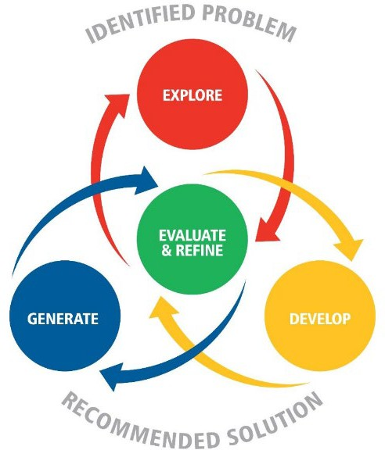
By using the problem-based learning framework, students develop confidence in dealing with complexity, as well as tolerance for ambiguity and persistence in working with difficult problems that may have many solutions. Students are able to communicate and work with others in order to achieve a common goal or solution. Students write computer programs to generate digital solutions that use data; require interactions with users and within systems; and affect people, the economy and environments. Solutions are generated using combinations of readily available hardware and software development environments, code libraries or specific instructions provided through programming. Some examples of digital solutions include instructions for a robotic system, an instructional game, a productivity application, products featuring interactive data, animations and websites.

Pathways
Digital Solutions is a General subject suited to students who are interested in pathways beyond school that lead to tertiary studies, vocational education or work. The subject prepares students for a range of careers in a variety of digital contexts. It develops thinking skills that are relevant for digital and non-digital real-world challenges. It prepares them to be successful in a wide range of careers and provides them with skills to engage in and improve the society in which we work and play. A course of study in Digital Solutions can establish a basis for further education and employment in the fields of AI Engineering, Cyber Security, Video Game Design, Data Science, Biomedical and Software Engineering.

Course Structure
Digital Solutions is a course of study consisting of four units. Subject matter, learning experiences and assessment increase in complexity from Units 1 and 2 to Units 3 and 4 as students develop greater independence as learners.
Unit 1 | Unit 2 | Unit 3 | Unit 4
Creating with code  - Understanding digital problems  - User experiences and interfaces  - Algorithms and programming techniques  - Programmed solutions | Application and data solutions  - Data-driven problems and solution requirements  - Data and programming techniques  - Prototype data solutions | Digital innovation  - Interactions between users, data and digital systems  - Real-world problems and solution requirements  - Innovative digital solutions | Digital impacts  - Digital methods for exchanging data  - Complex digital data exchange problems and solution requirements  - Prototype digital data exchanges

Assessment
Schools devise assessments in Units 1 and 2 to suit their local context. In Units 3 and 4 students complete for summative assessments. The results from each of the assessments are added together to provide a subject score out of 100. Students will also receive an overall subject result (A-E).
Unit 3 |  | Unit 4
Summative internal assessment 1 (IA1)  - Investigation – technical proposal | 25% | Summative internal assessment 3 (IA3)  - Digital solution | 25%
Summative internal assessment 2 (IA2)  - Digital solution | 25% | Summative internal assessment 3 (IA3)  - Digital solution | 25%

Engineering Skills | Applied Subject

Rationale
Engineering Skills includes the study of the manufacturing and engineering industry's practices and production processes through students' application in, and through trade learning contexts. Industry practices are used by manufacturing enterprises to manage the manufacture of products from raw materials. Production processes combine the production skills and procedures required to produce products, predominantly metal products in the engineering manufacturing industry. Students engage in applied learning to demonstrate knowledge and skills in units that meet local needs, available resources and teacher expertise. Through both individual and collaborative learning experiences, students learn to meet customer expectations of product quality at a specific price and time.

Applied learning supports students' development of transferable 21st century, literacy and numeracy skills relevant to future employment opportunities in the structural, transport and manufacturing engineering industrial sectors. Students learn to interpret drawings and technical information, and select and demonstrate safe practical production processes using hand and power tools, machinery and equipment. They communicate using oral, written and graphical modes, organise, calculate, plan, evaluate and adapt production processes and the products they produce. The majority of learning is done through manufacturing tasks that relate to business and industry. Students work with each other to solve problems and complete practical work.

Pathways
A course of study in Engineering skills can establish a basis for further education and employment. With additional training and experience, potential employment opportunities may be found in engineering trades as, for example, a sheet metal worker, metal fabricator, welder, maintenance fitter, metal machinist, locksmith, air-conditioning mechanic, refrigeration mechanic or automotive mechanic.

Course Structure
Core Topics | Unit 1 | Unit 2 | Unit 3 | Unit 4
Pathways | ✓ | ✓ | ✓ | ✓
Drawing and technical information | ✓ | ✓ | ✓ | ✓
Production processes | ✓ | ✓ | ✓ | ✓
Industry practices | ✓ | ✓ | ✓ | ✓

Assessment
Units 1 and 2 of the course are designed to allow students to begin their engagement with the course content,
i.e. the knowledge, understandings and skills of the subject. Course content, learning experiences and assessment increase in complexity across the four units as students develop greater independence as learners.

Units 3 and 4 consolidate student learning. Students will engage in one Practical Demonstration and one Project in each unit of work. A Practical demonstration uses skills associated with the Project. Each assessment instrument includes a practical component and visual evidence (digital portfolio). Each module is assessed against the approved QCAA standards matrix (A-E).

Year 11 |  | Year 12
Unit 1 | Unit 2  Fitting and Machining | Unit 3  Welding and fabrication | Unit 4
Module 1  - Project – Sheet Metal Toolbox | Module 2  - Project – Meat Tenderiser | Module 3  - Practical Demonstration  - Project – BBQ Barrel | Module 4  - Practical Demonstration  - Project – Smoker Box

Food & Nutrition | General Subject

Rationale
Food and Nutrition is the study of food in the context of food science, nutrition and food technologies. Students explore the chemical and functional properties of nutrients to create food solutions that maintain the beneficial nutritive values. This knowledge is fundamental for continued development of a safe and sustainable food system that can produce high quality, nutritious solutions with an extended shelf life. The food system includes the sectors of productions, processing, distribution, consumption, research and development. Waste management, sustainability and food protection are overarching concepts that have an impact on all sectors of the food system. Students will actively engage in a food and nutrition problem solving process to create food solutions that contribute positively to preferred person, social, ethical, economics, environmental, legal, sustainable and technological futures.

Food and Nutrition is a developmental course of study. In Unit 1, students develop an understanding of the chemical and functional properties of vitamins, minerals and protein, as well as food safety, spoilage and preservation. In Unit 2, students explore consumer food drivers, sensory profiling, labelling and food safety, and the development of food formulations. In Unit 3, students develop knowledge about the chemical, functional and sensory properties of carbohydrate and fat, and food safety, food preservation techniques and spoilage. In Unit 4, students develop an awareness of the interdisciplinary nature of food science, nutrition and technologies in relation to solving food and nutrition problems and improving safety, nutrition, convenience, transparency and accessibility for the consumer, as well as considering the wider impacts and implications of the solution. Using a problem-based learning approach, students learn to apply their food science, nutrition and technologies knowledge to solve real-world food and nutrition problems. This includes: exploring problems; developing ideas; generating, communicating the testing solutions; and evaluating the process and solutions. Students will integrate and use new and existing knowledge to make decisions and solve problems through investigation, experimentation and analysis.

Pathways
Food and Nutrition is a General subject suited to students who are interested in pathways beyond school that lead to further education, training and employment. A course of study in Food and Nutrition can establish a basis for further education and employment in the fields of Nutrition, Dietitian, Sports Science, Personal Trainers and Biological Science.

Course Structure
Unit 1 | Unit 2 | Unit 3 | Unit 4
Food science of vitamins, minerals and protein  - Topic 1: Introduction to the food system  - Topic 2: Vitamins and minerals  - Topic 3: Protein  - Topic 4: Developing food solutions | Food drivers and emerging trends  - Topic 1: Consumer food drivers  - Topic 2: Sensory profiling  - Topic 3: Labelling and food safety  - Topic 4: Food formulation for consumer markets | Food science of carbohydrate and fat  - Topic 1: The food system  - Topic 2: Carbohydrate  - Topic 3: Fat  - Topic 4: Developing food solutions | Food solution development for nutrition consumer markets  - Topic 1: Formulation and reformulation for nutrition consumer markets  - Topic 2: Food development process
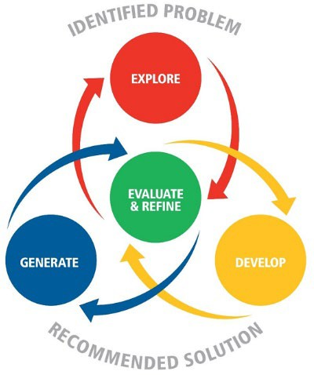

Assessment
Students should have opportunities in Units 1 and 2 to experience and respond to the types of assessment they will encounter in Units 3 and 4.
For reporting purposes, schools should develop at least one assessment per unit, with a maximum of four assessment across Units 1 and 2.
Unit 3 |  | Unit 4
Summative internal assessment 1 (IA1):  - Examination  A combination of short response questions and one extended question. | 25% | Summative internal assessment 3 (IA3):  - Food and Nutrition Solution  Students documenting the application of a problem-solving process in response to an identified real-world problem that requires a  solution. | 25%
Summative internal assessment 2 (IA2):  - Food and Nutrition Solution  Students documenting the application of a problem-solving process in response to an identified real-world problem that requires  a solution. | 25% | Summative external assessment (EA):  - Examination  A combination of short response questions and one extended response question. | 25%

Industrial Technology Skills | Applied Subject

Rationale
Industrial Technology Skills includes the study of industry practices and production processes through students' application in and through trade learning contexts in a range of industrial sector industries, including building and construction, engineering, and furnishing. Industry practices are used by industrial sector enterprises to manage the manufacture of products from raw materials. Production processes combine the production skills and procedures required to produce products. Students engage in applied learning to demonstrate knowledge and skills of the core learning in units that meet local needs, available resources and teacher expertise. Through both individual and collaborative learning experiences, students learn to meet customer expectations of product quality at a specific price and time.

Applied learning supports students' development of transferable 21st century, literacy, and numeracy skills relevant to a variety of industries. Students learn to interpret drawings and technical information, select, and demonstrate safe practical production processes using hand/power tools, machinery and equipment, communicate using oral, written and graphical modes, organise, calculate, plan, evaluate and adapt production processes and the products they produce. The majority of learning is done through manufacturing tasks that relate to business and industry. Students work with each other to solve problems and complete practical work.

Pathways
A course of study in Industrial Technology Skills can establish a basis for further education and employment in manufacturing industries, and help students understand the different careers available. With additional training and experience, potential employment opportunities may be found in the industry areas of building and construction, surveying, carpentry, electrical, plumbing, furnishing, cabinet making, drywall installation, roofing and masonry.

Course Structure
The Industrial Technology Skills course is designed around:
- core topics, which are integrated throughout the course
- elective topics, organised in industry areas, and manufacturing tasks related to the specific units of study.
Core Topics | Industry Area | Units of study
- Pathways  - Drawings and technical information  - Production processes  - Industry Practices | - Building and Construction | - Site Preparation and foundations  - Framing and cladding
 | - Furnishing skills | - Furniture making  - Cabinet making

Assessment
Units 1 and 2 of the course are designed to allow students to begin their engagement with the course content, ie. the knowledge, understandings and skills of the subject. Course content, learning experiences and assessment increase in complexity across the four units as students develop greater independence as learners.

Units 3 and 4 consolidate student learning. Students will engage in one Practical Demonstration and one Project in each unit of work. A Practical demonstration uses skills associated with the Project. Each assessment instrument includes a practical component and visual evidence (digital portfolio). Each module is assessed against the approved QCAA standards matrix (A-E).

Year 11 |  | Year 12
Unit 1 | Unit 2 | Unit 3 | Unit 4
Module 1:  - Practical Demonstration  - Project – Outdoor Entertainers Unit | Module 2:  - Practical Demonstration  - Project – CNC Contemporary Furniture | Module 3:  - Practical Demonstration  - Project – Live Edge Resin Table | Module 4:  - Practical Demonstration  - Project – Community Project
Building and construction - Framing and cladding | Furniture Skills - Cabinet making | Furniture Skills - Furniture making | Building and construction - Site Preparation and  foundations

Information & Communication Technology | Applied Subject

Rationale
Technologies are an integral part of society as humans seek to create solutions to improve their own and others’ quality of life. Technologies affect people and societies by transforming, restoring and sustaining the world in which we live. In an increasingly technological and complex world, it is important to develop the knowledge, understanding and skills associated with information technology to support a growing need for digital literacy and specialist information and communication technology skills in the workforce. Across business, industry, government, education and leisure sectors, rapidly changing industry practices and processes create corresponding vocational opportunities in Australia and around the world.
Information & Communication Technology includes the study of industry practices and ICT processes through students’ application in and through a variety of industry-related learning contexts. Industry practices are used by enterprises to manage ICT product development processes to ensure high-quality outcomes, with alignment to relevant local and universal standards and requirements. Students engage in applied learning to demonstrate knowledge, understanding and skills in units that meet local needs, available resources and teacher expertise. Through both individual and collaborative learning experiences, students learn to meet client expectations and product specifications.
Applied learning supports students’ development of transferable 21st century, literacy and numeracy skills relevant to information and communication technology sectors and future employment opportunities. Students learn to interpret client briefs and technical information and select and demonstrate skills using hardware and software to develop ICT products. The majority of learning is done through prototyping tasks that relate to business and industry, and that promote adaptable, competent, self-motivated and safe individuals who can work with colleagues to solve problems and complete practical work.

Pathways
ICT prepares students for further education, training, and employment in ICT-related fields. It supports career development in areas such as:
- web and app development
- audio and video production
- digital imaging and modelling
- robotics and automation
- technical support and IT services.

This subject also builds foundational skills for vocational pathways and certificate programs in digital technologies and creative industries.

Course Structure
The Information & Communication Technology course is structured around four units selected from six possible focus areas. Each unit explores a different aspect of ICT and involves hands-on learning through the design and production of digital solutions that respond to real-world problems and client needs.
Robotics
  - Design and prototype robot or drone products
  - Apply programming skills and hardware integration
  - Explore automation and emerging technologies

App Development
  - Develop native mobile applications
  - Learn user interface (UI) and user experience (UX) design
  - Use development environments and frameworks for app creation
Audio and Video Production
  - Plan, produce and edit multimedia content
  - Use industry-standard tools for sound and video
  - Create products such as ads, interviews or promotional clips
Layout and Publishing
  - Design print and digital communication materials
  - Apply visual design principles and typography
  - Create brochures, magazines, posters and more
Digital Imaging and Modelling
  - Create and manipulate digital graphics and 3D models
  - Use software tools for illustration, photo editing, and modelling
  - Focus on technical accuracy and creative expression
Web Development
  - Design and build responsive websites and web apps
  - Use HTML, CSS and other web technologies
  - Apply accessibility, usability and user experience principles

Each unit encourages students to respond to client briefs, work collaboratively, and apply ICT industry practices to produce professional-quality digital products.

Assessment
Assessment is conducted through a variety of practical and theoretical tasks, including:
- Product Proposals: Students interpret briefs and propose ICT solutions using low-fidelity prototypes
- Projects: Students produce high-fidelity ICT products and document their process through multimodal presentations.

In Units 3 & 4, four assessments are completed and graded A–E. These include at least one proposal and one project per unit. Assessments are aligned to the following objectives:
- demonstrate industry practices, skills and processes
- interpret client briefs and technical information
- select, sequence, evaluate and adapt ICT processes and products.

Cert III in Hospitality – SIT30616 | VET Subject

Rationale
According to the Australian Government's Job Outlook Service, employment in Accommodation and Food Services is projected to grow by 13.2% over the next four years to November 2026, with a prediction of over 200,000 job opportunities. Cafes, Restaurants and Food Service Industry is the largest sector in the Accommodation and Food Services industry, employing 71.5% of workers.

The Certificate III in Hospitality has been designed as a foundation level qualification for students who have a passion for the hospitality industry. This course will offer students the chance to discover the various exciting career pathways in hospitality. Students will learn safe work practices, customer service, hygienic practices for food safety and they will discover how to coach others in job skills and enhance their cultural sensitivity.

Certificate III in Hospitality is a stand-alone VET subject where students complete in school hours in Year 11 and Year 12. The course is competency-based meaning students work to develop the skills and knowledge required in each of The Electives. Students will be progressively assessed in individual Core Units or Elective Units. To be assessed as competent, a student must demonstrate to a qualified assessor that they can effectively carry out the tasks listed to the standard required in the appropriate industry. There is no mark awarded in competency-based assessments as students will either be assessed as either 'competent' or 'not yet competent'.

Upon successful completion, Certificate III in Hospitality will be awarded by an external Registered Training Organisation (RTO). This certificate is nationally recognised.

What students will learn:
- Gain an understanding of the hospitality industry including how to apply skills effectively.
- Strategies to work effectively in a team environment, customer services skills, and how to coach and train staff.
- Hospitality essentials such as responsible service of alcohol, preparation and service of non-alcoholic beverages, espresso coffee and food.
- Business essentials such as how to process financial transactions, product business documents and apply effective communication skills.

Pathways
Certificate III in Hospitality qualification provides a pathway to work in organisations such as airlines, restaurants, hotels, motels, clubs, pubs, cafes, and coffee shops.

Course Structure
As a guide, the following Core Units will be studied in this qualification: These units are mandatory:
BSBWOR203 | Work effectively with others
SITHIND002 | Source and use information on the hospitality industry
SITHIND004 | Work effectively in hospitality service
SITXCCS006 | Provide service to customers
SITXCOM002 | Show social and cultural sensitivity
SITXWHS001 | Participate in safe work practices
SITXHRM001 | Coach others in job skills

These units are elective:
SITXFSA001 | Use hygienic practices for food safety
SITHFAB002 | Provide responsible service of alcohol
SITHCCC002 | Prepare and present simple dishes
SITHCCC006 | Prepare appetisers and salads
SITHFAB004 | Prepare and serve non-alcoholic beverages
SITHFAB005 | Prepare and serve espresso coffee
SITHFAB007 | Serve food and beverage
SITHFAB003 | Operate a bar
SITXFIN001 | Process financial transactions

Required Equipment and Costs
A Hospitality uniform must be purchased by the student for front and back of house operations.
An additional cost for some industry experience placements may be incurred.

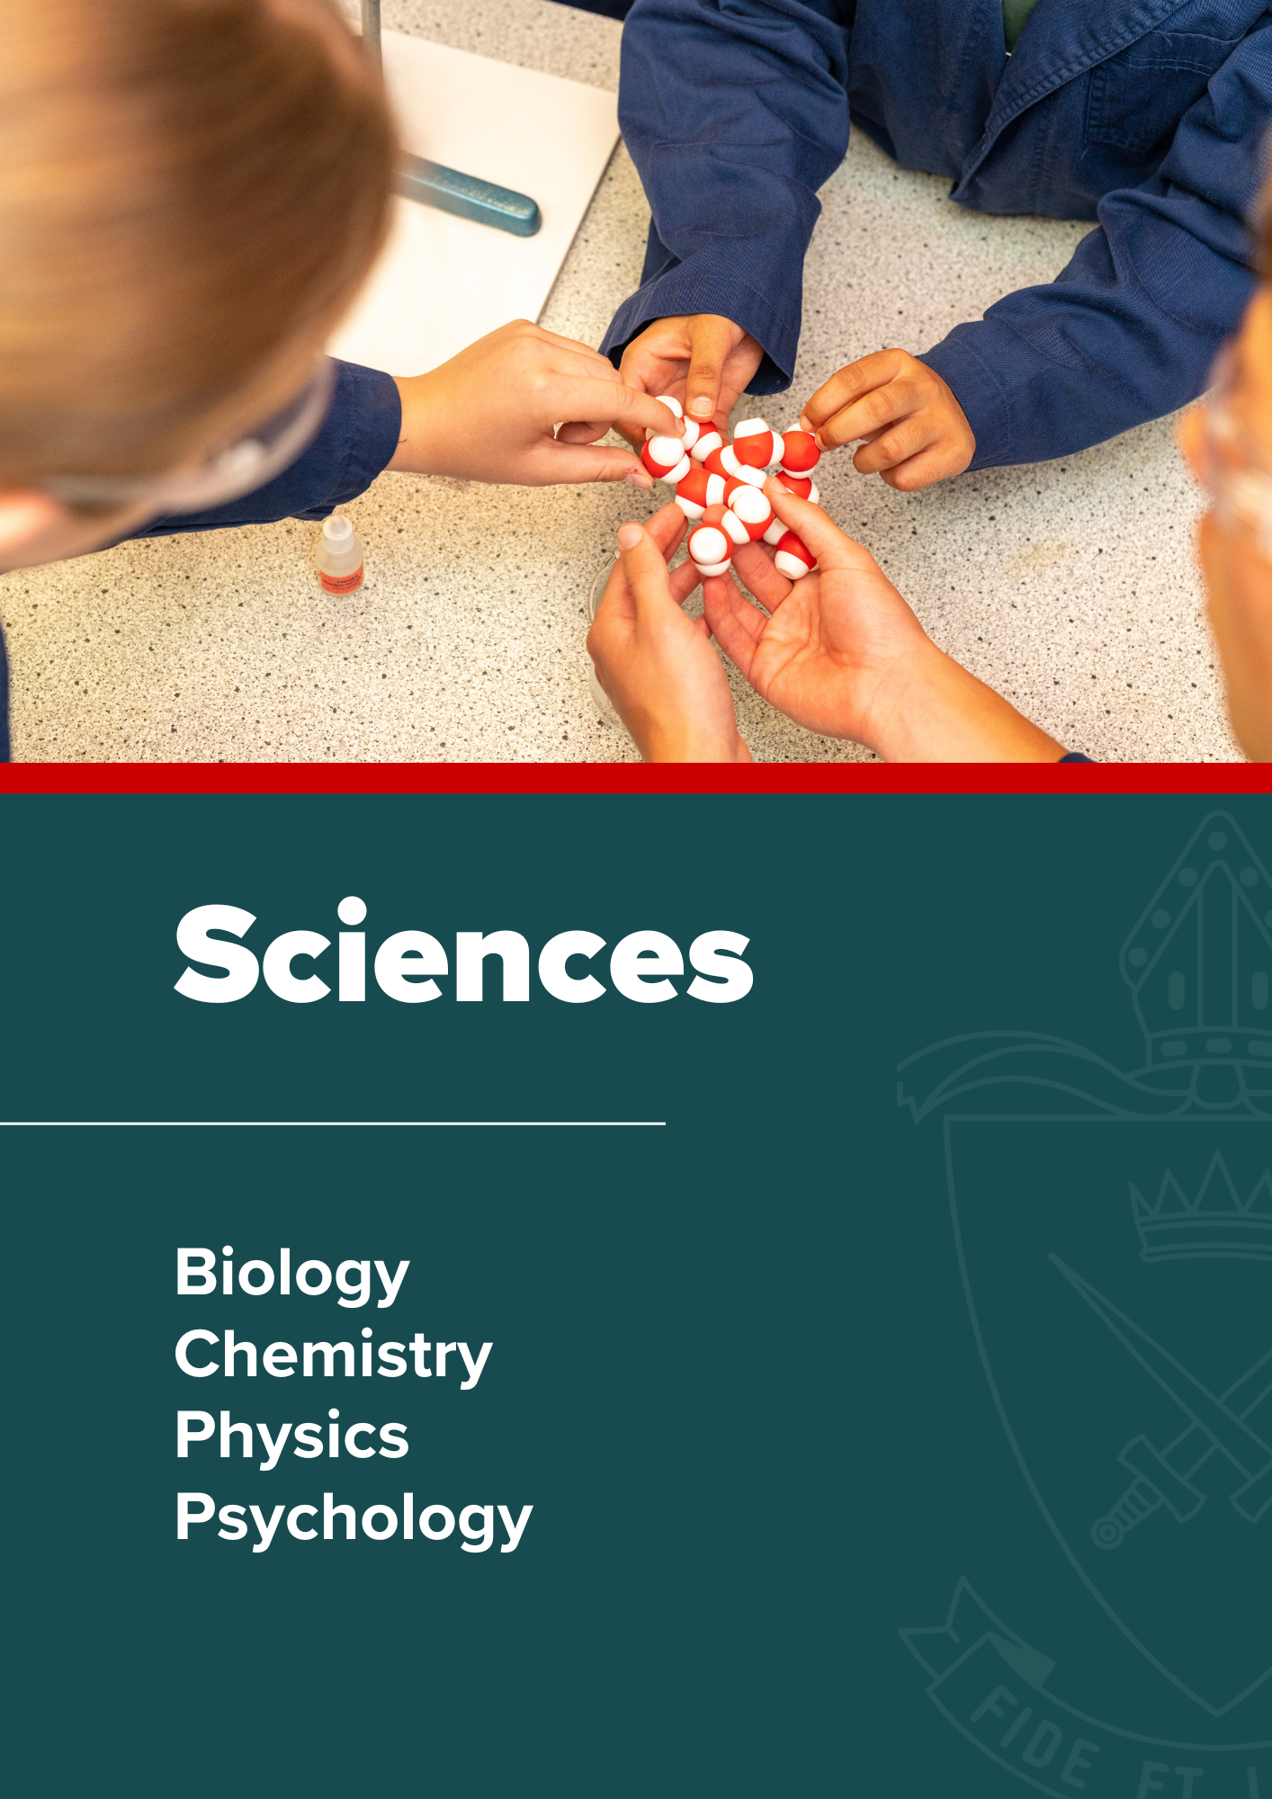

Sciences

Biology | General Subject

Rationale
Biology provides opportunities for students to engage with living systems. In Unit 1, students develop their understanding of cells and multicellular organisms. In Unit 2, they engage with the concept of maintaining the internal environment. In Unit 3, students study biodiversity and the interconnectedness of life. This knowledge is linked in Unit 4 with the concepts of heredity and the continuity of life.
Students will learn valuable skills required for the scientific investigation of questions. In addition, they will become citizens who are better informed about the world around them and who have the critical skills to evaluate and make evidence-based decisions about current scientific issues.
Biology aims to develop students’:
- sense of wonder and curiosity about life
- respect for all living things and the environment
- understanding of how biological systems interact and are interrelated, the flow of matter and energy through and between these systems, and the processes by which they persist and change
- understanding of major biological concepts, theories and models related to biological systems at all scales, from subcellular processes to ecosystem dynamics
- appreciation of how biological knowledge has developed over time and continues to develop; how scientists use biology in a wide range of applications; and how biological knowledge influences society in local, regional and global contexts
- ability to plan and carry out fieldwork, laboratory and other research investigations, including the collection and analysis of qualitative and quantitative data and the interpretation of evidence
- ability to use sound, evidence-based arguments creatively and analytically when evaluating claims and applying biological knowledge
- ability to communicate biological understanding, findings, arguments and conclusions using appropriate representations, modes and genres.

Pathways
A course of study in Biology can establish a basis for further education and employment in the fields of medicine, forensics, veterinary, food and marine sciences, agriculture, biotechnology, environmental rehabilitation, biosecurity, quarantine, conservation and sustainability.

Objectives
By the conclusion of the course of study, students will:
- describe ideas and findings
- apply understanding
- analyse data
- interpret evidence
- evaluate conclusions, claims and processes
- Investigate phenomena.

Course Structure
Unit 1 | Unit 2 | Unit 3 | Unit 4
Cells and multicellular organisms  - Cells as the basis of life  - Exchange of nutrients and wastes  - Cellular energy, gas exchange and plant physiology | Maintaining the internal environment  - Homeostasis  - Infectious disease and epidemiology | Biodiversity and the interconnectedness of life  - Biodiversity and populations  - Functioning ecosystems and succession | Heredity and continuity of life  - Genetics and heredity  - Continuity of life on Earth

Assessment
In Units 1 and 2 students complete four summative assessments: Data Test, Student Experiment, Research Investigation and an Exam.
In Units 3 and 4 students complete four summative assessments. The results from each of the assessments are added together to provide a subject score out of 100. Students will also receive an overall subject result (A–E).
Unit 3 |  | Unit 4
Summative internal assessment 1 (IA1)  - Data test | 10% | Summative internal assessment 3 (IA3)  - Research investigation | 20%
Summative internal assessment 2 (IA2)  - Student experiment | 20%
Summative external assessment (EA)50%
- Examination — combination response

Required Resources
Pearson Biology 11 QLD Skills and Assessment book
Pearson Biology 12 QLD Skills and Assessment book

Chemistry | General Subject

Rationale
Chemistry is the study of materials, their properties and structure. In Unit 1, students study atomic theory, chemical bonding, and the structure and properties of elements and compounds. In Unit 2, students explore intermolecular forces, gases, aqueous solutions, acidity and rates of reaction. In Unit 3, students study equilibrium processes and redox reactions. In Unit 4, students explore organic chemistry, synthesis and design to examine the characteristic chemical properties and chemical reactions displayed by different classes of organic compounds.
Chemistry aims to develop students’:
- interest in and appreciation of chemistry and its usefulness in helping to explain phenomena and solve problems encountered in their ever-changing world
- understanding of the theories and models used to describe, explain and make predictions about chemical systems, structures and properties
- understanding of the factors that affect chemical systems and how chemical systems can be controlled to produce desired products
- appreciation of chemistry as an experimental science that has developed through independent and collaborative research, and that has significant impacts on society and implications for decision-making
- expertise in conducting a range of scientific investigations, including the collection and analysis of qualitative and quantitative data, and the interpretation of evidence
- ability to critically evaluate and debate scientific arguments and claims in order to solve problems and generate informed, responsible and ethical conclusions
- ability to communicate chemical understanding and findings to a range of audiences, including through the use of appropriate representations, language and nomenclature.

Pathways
A course of study in Chemistry can establish a basis for further education and employment in the fields of forensic science, environmental science, engineering, medicine, pharmacy and sports science.

Objectives
By the conclusion of the course of study, students will:
- describe ideas and findings
- apply understanding
- analyse data
- interpret evidence
- evaluate conclusions, claims and processes
- investigate phenomena.

Course Structure
Unit 1 | Unit 2 | Unit 3 | Unit 4
Chemical fundamentals  — structure, properties and reactions  - Properties and structure of atoms  - Properties and structure of materials  - Chemical reactions  —reactants, products and energy change | Molecular interactions and reactions  - Intermolecular forces and gases  - Aqueous solutions and acidity  - Rates of chemical reactions | Equilibrium, acids and redox reactions  - Chemical equilibrium systems  - Oxidation and reduction | Structure, synthesis and design  - Properties and structure of organic materials  - Chemical synthesis and design

Assessment
In Units 1 and 2 students complete four summative assessments: Data Test, Student Experiment, Research Investigation and an Exam.
In Units 3 and 4 students complete four summative assessments. The results from each of the assessments are added together to provide a subject score out of 100. Students will also receive an overall subject result (A–E).
Unit 3 |  | Unit 4
Summative internal assessment 1 (IA1)  - Data test | 10% | Summative internal assessment 3 (IA3)  - Research investigation | 20%
Summative internal assessment 2 (IA2)  - Student experiment | 20%
Summative external assessment (EA)50%
- Examination — combination response

Required Resources
Pearson Chemistry 11 QLD Skills and Assessment book
Pearson Chemistry 12 QLD Skills and Assessment book

Physics | General Subject

Rationale
Physics provides opportunities for students to engage with the classical and modern understandings of the universe. In Unit 1, students learn about the fundamental concepts of thermodynamics, electricity and nuclear processes. In Unit 2, students learn about the concepts and theories that predict and describe the linear motion of objects. Further, they will explore how scientists explain some phenomena using an understanding of waves. In Unit 3, students engage with the concept of gravitational and electromagnetic fields, and the relevant forces associated with them. Finally, in Unit 4, students study modern physics theories and models that, despite being counterintuitive, are fundamental to our understanding of many common observable phenomena.
Students will learn valuable skills required for the scientific investigation of questions. In addition, they will become citizens who are better informed about the world around them, and who have the critical skills to evaluate and make evidence-based decisions about current scientific issues.
Physics aims to develop students’:
- appreciation of the wonder of physics and the significant contribution physics has made to contemporary society
- understanding that diverse natural phenomena may be explained, analysed and predicted using concepts, models and theories that provide a reliable basis for action
- understanding of the ways in which matter and energy interact in physical systems across a range of scales
- understanding of the ways in which models and theories are refined, and new models and theories are developed in physics; and how physics knowledge is used in a wide range of contexts to inform personal, local and global issues
- investigative skills, including the design and conduct of investigations to explore phenomena and solve problems
- the collection and analysis of qualitative and quantitative data, and the interpretation of evidence
- ability to use accurate and precise measurement, valid and reliable evidence, and scepticism and intellectual rigour to evaluate claims
- ability to communicate physics understanding, findings, arguments and conclusions using appropriate representations, modes and genres.

Pathways
A course of study in Physics can establish a basis for further education and employment in the fields of science, engineering, medicine and technology.

Objectives
By the conclusion of the course of study, students will:
- describe ideas and findings
- apply understanding
- analyse data
- interpret evidence
- evaluate conclusions, claims and processes
- investigate phenomena

Course Structure
Unit 1 | Unit 2 | Unit 3 | Unit 4
Thermal, nuclear and electrical physics  - Heating processes  - Ionising radiation and nuclear reactions  - Electrical circuits | Linear motion and waves  - Linear motion and force  - Waves | Gravity and electromagnetism  - Gravity and motion  - Electromagnetism | Revolutions in modern physics  - Special relativity  - Quantum theory  - The Standard Model

Assessment
In Units 1 and 2 students complete four summative assessments: Data Test, Student Experiment, Research Investigation and an Exam.
In Units 3 and 4 students complete four summative assessments. The results from each of the assessments are added together to provide a subject score out of 100. Students will also receive an overall subject result (A–E).
Unit 3 |  | Unit 4
Summative internal assessment 1 (IA1)  - Data test | 10% | Summative internal assessment 3 (IA3)  - Research investigation | 20%
Summative internal assessment 2 (IA2)  - Student experiment | 20%
Summative external assessment (EA) 50%
- Examination — combination response

Required Resources
Pearson Physics 11 QLD Skills and Assessment book Pearson Physics 12 QLD Skills and Assessment book

Psychology | General Subject

Rationale
Psychology provides opportunities for students to engage with concepts that explain behaviours and underlying cognitions. In Unit 1, students examine individual development in the form of the role of the brain, cognitive development, human consciousness and sleep. In Unit 2, students investigate the concept of intelligence, the contribution of emotion and motivation on individual behaviour, and the process of diagnosis and how to classify psychological disorders and determine an effective treatment.. In Unit 3, students examine individual thinking and how it is determined by the brain, including perception, memory, and learning. In Unit 4, students consider the influence of others by examining theories of social psychology, interpersonal processes, attitudes and cross-cultural psychology.

Psychology aims to develop students’:
- interest in psychology and their appreciation for how this knowledge can be used to understand contemporary issues
- appreciation of the complex interactions, involving multiple parallel processes that continually influence human behaviour
- understanding that psychological knowledge has developed over time and is used in a variety of contexts, and is informed by social, cultural and ethical considerations
- ability to conduct a variety of field research and laboratory investigations involving collection and analysis of qualitative and quantitative data and interpretation of evidence
- ability to critically evaluate psychological concepts, interpretations, claims and conclusions with reference to evidence
- ability to communicate psychological understandings, findings, arguments and conclusions using appropriate representations, modes and genres.

Pathways
A course of study in Psychology can establish a basis for further education and employment in the fields of psychology, sales, human resourcing, training, social work, health, law, business, marketing and education.

Objectives
By the conclusion of the course of study, students will:
- describe ideas and findings
- apply understanding
- analyse data
- interpret evidence
- evaluate conclusions, claims and processes
- investigate phenomena

Course Structure
Unit 1 | Unit 2 | Unit 3 | Unit 4
Individual development  - The role of the brain  - Cognitive development  - Consciousness, attention and sleep | Individual behaviour  - Intelligence  - Diagnosis  - Psychological disorders and treatments  - Emotion and motivation | Individual thinking  - Brain function  - Sensation and perception  - Memory  - Learning | The influence of others  - Social psychology  - Interpersonal processes  - Attitudes  - Cross-cultural psychology

Assessment
In Units 1 and 2 students complete four summative assessments: Data Test, Student Experiment, Research Investigation and an Exam.
In Units 3 and 4 students complete four summative assessments. The results from each of the assessments are added together to provide a subject score out of 100. Students will also receive an overall subject result (A–E).
Unit 3 |  | Unit 4
Summative internal assessment 1 (IA1)  - Data test | 10% | Summative internal assessment 3 (IA3)  - Research investigation | 20%
Summative internal assessment 2 (IA2)  - Student experiment | 20%
Summative external assessment (EA)50%
- Examination — combination response

Required Resources
Psychology for Queensland Units 1 & 2 Student Workbook
Psychology for Queensland Units 3 & 4 Student Workbook

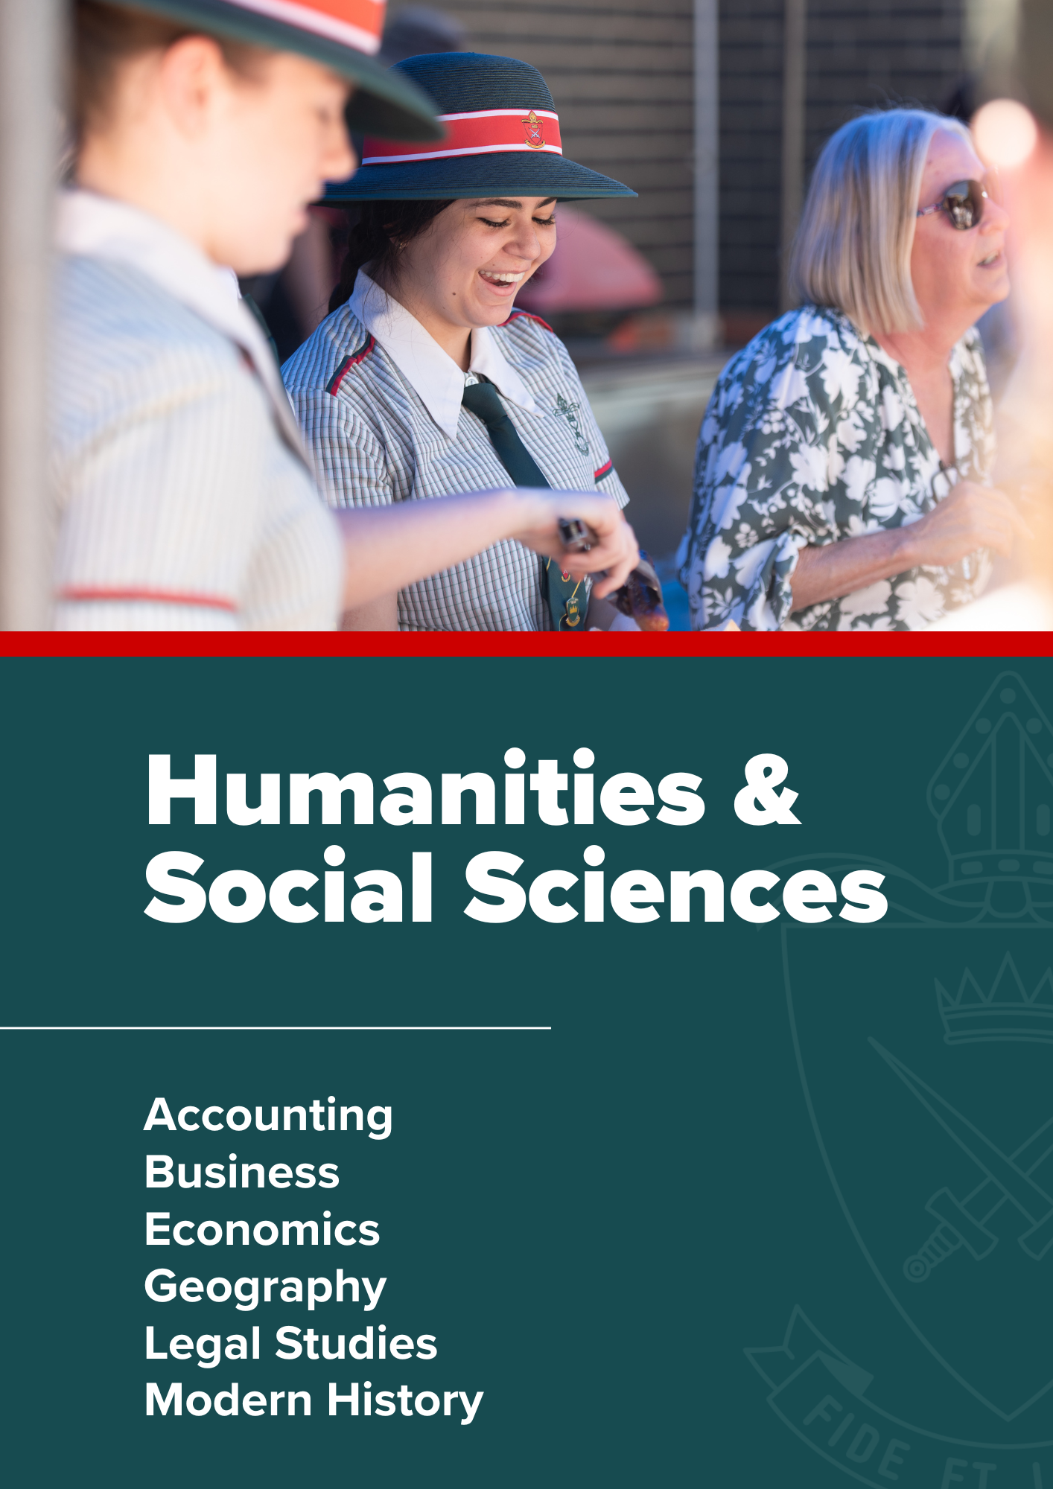

Humanities & Social Sciences

Accounting | General Subject

Rationale
Accounting is a universal discipline, encompassing the successful management of financial resources of the public sector, businesses, and individuals. It is foundational to all organisations across all industries and assists in discharging accountability and financial control. Accounting is a way of systematically organising, critically analysing and communicating financial data and information for decision-making. The overarching context for this syllabus is the real-world expectation that accounting provides real-time processing of transactions with a minimum of monthly and yearly reporting. Digital technologies are integral to accounting, enabling real-time access to vital financial information.

When students study this subject, they develop an understanding of the essential role accounting plays in the successful performance of any organisation. Students learn fundamental accounting concepts in order to develop an understanding of accrual accounting, managerial and accounting controls, internal and external financial statements, and ratio analysis. Students are then ready for more complex utilisation of knowledge, allowing them to synthesise financial and other information, evaluate accounting practices, solve authentic accounting problems and make and communicate recommendations.

Accounting is for students with a special interest in business, commerce, entrepreneurship and the personal management of financial resources. The numerical, literacy, technical, financial, critical thinking, decision-making and problem-solving skills learned in Accounting enrich the personal and working lives of students. Problem-solving and the use of authentic and diversified accounting contexts provide opportunity for students to develop an understanding of the ethical attitudes and values required to participate more effectively and responsibly in a changing business environment.

Pathways
Accounting is a General subject suited to students who are interested in pathways beyond school that lead to tertiary studies, vocational education, or work. A course of study in Accounting can establish a basis for further education and employment in the fields of accounting, business, management, banking, finance, law, economics, and commerce. As the universal language of business (Helliar 2013), Accounting provides students with a variety of future opportunities, enabling a competitive advantage in entrepreneurship and business management in many types of industries, both locally and internationally.

Course Structure
Accounting is a course of study consisting of four units. Subject matter, learning experiences and assessment increase in complexity from Units 1 and 2 to Units 3 and 4 as students develop greater independence as learners.
Units 1 and 2 provide foundational learning, which allows students to experience all syllabus objectives and begin engaging with the course subject matter. Students should complete Units 1 and 2 before beginning Unit 3 and Unit 4. Units 3 and 4 consolidate student learning. Only the results from Units 3 and 4 will contribute to ATAR calculations.
The structure of this course of study is outlined below.
Each unit has been developed with a notional time of 55 hours of teaching and learning, including assessment.

Unit 1 | Unit 2 | Unit 3 | Unit 4
Real-world accounting  - Introduction to accounting  - Accounting for today’s businesses | Financial reporting  - End-of-period reporting for today’s businesses  - Performance analysis of a sole trader business | Managing resources  - Cash management  - Managing resources for a sole trader business | Accounting — the big picture  - Fully classified financial statement reporting and analysis for a sole trader business  - Complete accounting process for a sole trader business  - Performance analysis of a public company

Assessment
Schools devise assessments in Units 1 and 2 to suit their local context.
In Units 3 and 4 students complete four summative assessments. The results from each of the assessments are added together to provide a subject score out of 100. Students will also receive an overall subject result (A–E).
Unit 3 |  | Unit 4
Summative internal assessment 1 (IA1):  - Project — cash management | 25% | Summative internal assessment 3 (IA3):  - Examination — combination response | 25%
Summative internal assessment 2 (IA2):  - Examination — combination response | 25% | Summative external assessment (EA):  - Examination — combination response | 25%

Business | General Subject

Rationale
Business is multifaceted. It is a contemporary discipline with representation in every aspect of society including individuals, community and government. Business, as a dynamic and evolving discipline, is responsive to environmental changes such as emerging technologies, globalisation, sustainability, resources, economy and society.

The study of business is relevant to all individuals in a rapidly changing, technology-focused and innovation- driven world. Through studying Business, students are challenged academically and exposed to authentic and real-life practices. The knowledge and skills developed in Business will allow students to contribute meaningfully to society, the workforce and the marketplace and prepare them as potential employees, employers, leaders, managers and entrepreneurs of the future.

Students investigate the business life cycle from the seed to post-maturity stage and develop skills in examining business data and information (see Section 1.2.5). Students learn business concepts, theories, processes and strategies relevant to leadership, management and entrepreneurship. A range of business environments and situations is explored. Through this exploration, students investigate the influence on and implications for strategic development in the functional areas of finance, human resources, marketing and operations.
Learning in Business integrates an inquiry approach with authentic case studies. Students become critical observers of business practices by applying an inquiry process in undertaking investigations of business situations. They use a variety of technological, communication and analytical tools to comprehend, analyse and interpret business data and information. Students evaluate strategies using criteria that are flexible, adaptable and underpinned by communication, leadership, creativity and sophistication of thought.

This multifaceted course creates a learning environment that fosters ambition and success, while being mindful of social and ethical values and responsibilities. Opportunity is provided to develop interpersonal and leadership skills through a range of individual and collaborative activities in teaching and learning.
Business develops students’ confidence and capacity to participate as members or leaders of the global workforce through the integration of 21st century skills.

Business allows students to engage with the dynamic business world (in both national and global contexts), the changing workforce and emerging digital technologies. It addresses contemporary implications, giving students a competitive edge in the workplace as socially responsible and ethical members of the business community, and as informed citizens, employees, consumers and investors.

Pathways
Business is a General subject suited to students who are interested in pathways beyond Year 12 that lead to tertiary studies, vocational education or work. The study of Business provides opportunities for students to pursue entrepreneurial pathways and a wide range of careers in the public, private and not-for-profit sectors. A course of study in Business can establish a basis for further education and employment in the fields of business management, business development, entrepreneurship, business analytics, economics, business law, accounting and finance, international business, marketing, human resources management and business information systems.

Course Structure
Unit 1 | Unit 2 | Unit 3 | Unit 4
Business creation  - Fundamentals of business  - Creation of business ideas | Business growth  - Establishment of a business  - Entering markets | Business diversification  - Competitive markets  - Strategic development | Business evolution  - Repositioning a business  - Transformation of a business

Assessment
Schools devise assessments in Units 1 and 2 to suit their local context. In Units 3 and 4 students complete four summative assessments. The results from each of the assessments are added together to provide a subject score out of 100. Students will also receive an overall subject result (A-E).
Unit 3 |  | Unit 4
Summative internal assessment 1 (IA1):  - Examination – combination response | 25% | Summative internal assessment 3 (IA3):  - Extended response – feasibility report | 25%
Summative internal assessment 2 (IA2):  - Investigation – business report | 25% | Summative external assessment (EA):  - Examination – combination response | 25%

Economics | General Subject

Rationale
The discipline of economics is integral to every aspect of our lives: our employment opportunities, business operations and living standards. The subject challenges us to use evidence and be innovative when solving problems in a world of complex global relationships and trends, where a knowledge of economic forces and flows leads to better decisions. In Economics, decision-making is core: how to allocate and distribute scarce resources to maximise well-being.

Economic literacy is essential for understanding current issues: to make informed judgments and participate effectively in society. Students develop knowledge and cognitive skills to comprehend, apply analytical processes and use economic knowledge. They examine data and information to determine validity, and consider economic policies from various perspectives. Economic models and analytical tools are used to investigate and evaluate outcomes to draw conclusions. In the process, students appreciate ideas, viewpoints and values underlying economic issues.
The field of economics is typically divided into two: microeconomics being the study of individuals, households and businesses; and macroeconomics, the study of economy-wide phenomena. Within this context, students study opportunity costs, economic models and the market forces of demand and supply. These concepts are applied to real world issues of how and why markets may be modified, and the effects of government strategies and interventions. The final units of the course dissect and interpret the complex nature of international economic relationships and the dynamics of Australia’s place in the global economy. This segues to Australian economic management, as students analyse trends and evaluate economic policies.
Curiosity is essential when studying Economics — how can we best use and allocate resources and production, and what are the consequences of trade-offs? Accordingly, learning is centred on an inquiry approach that facilitates reflection and metacognitive awareness. Intellectual rigour is sharpened by the appraisal of a variety of often-contradictory data and information, which tests the role of assumptions in economic models, ideas and perspectives.

In the 21st century, the study of economics develops the transferable skills of critical thinking and questioning assumptions. As students develop intellectual flexibility, digital literacy and economic thinking skills, they increase the tertiary pathways and opportunities in the workplace open to them.

Economics is based on possibility and optimism. It appeals to students from Humanities and Business, and those interested in the broader relevance of Mathematics, Technology and Science because of their connection with economic forces. The subject positions students to think deeply about the challenges that confront individuals, business and government, and provides students with tools to think creatively beyond what is known and predictable.

Pathways
Economics is a General subject suited to students who are interested in pathways beyond school that lead to tertiary studies, vocational education or work. A course of study in Economics can establish a basis for further education and employment in the fields of economics, econometrics, management, data analytics, business, accounting, finance, actuarial science, law and political science. Economics is an excellent complement for students who want to solve real world science or environmental problems and participate in government policy debates. It provides a competitive advantage for career options where students are aiming for management roles and developing their entrepreneurial skills to create business opportunities as agents of innovation.

Course Structure
Unit 1 | Unit 2 | Unit 3 | Unit 4
Markets and models  - The basic economic problem  - Economic flows  - Market forces | Modified markets  - Markets and efficiency  - Case options of market measures and strategies | International economics  - International trade  - Global economic issues | Contemporary macroeconomics  - Macroeconomic objectives and theory  - Economic indicators and past budget stances  - Economic management

Assessment
Schools devise assessments in Units 1 and 2 to suit their local context.
In Units 3 and 4 students complete four summative assessments. The results from each of the assessments are added together to provide a subject score out of 100. Students will also receive an overall subject result (A-E).
Unit 3 |  | Unit 4
Summative internal assessment 1 (IA1):  - Examination — combination response | 25% | Summative internal assessment 3 (IA3):  - Examination — extended response | 25%
Summative internal assessment 2 (IA2):  - Investigation | 25% | Summative external assessment (EA):  - Examination — combination response | 25%

Geography | General Subject

Rationale
Geography teaches us about the significance of ‘place’ and ‘space’ in understanding our world. These two concepts are foundational to the discipline, with the concepts of environment, interconnection, sustainability, scale and change building on this foundation. By observing and measuring spatial, environmental, economic, political, social and cultural factors, geography provides a way of thinking about contemporary challenges and opportunities.

This course of study enables students to appreciate and promote a more sustainable way of life. Through analysing and applying geographical knowledge, students develop an understanding of the complexities involved in sustainable planning and management practices. Geography aims to encourage students to become informed and adaptable, so they develop the skills required to interpret global concerns and make genuine and creative contributions to society. It contributes to their development as global citizens who recognise the challenges of sustainability and the implications for their own and others’ lives.
Geography aims to develop students’:

- literacy — the set of knowledge and skills about language and texts essential for understanding and conveying Geography content;
- numeracy — the knowledge, skills, behaviours and dispositions that students need to use mathematics in a wide range of situations, to recognise and understand the role of mathematics in the world, and to develop the dispositions and capacities to use mathematical knowledge and skills purposefully; and
- 21st century skills — the attributes and skills students need to prepare them for higher education, work and engagement in a complex and rapidly changing world.

Pathways
Geography is a General subject suited to students who are interested in pathways beyond school that lead to tertiary studies, vocational education or work. A course of study in Geography can establish a basis for further education and employment in the fields of urban and environmental design, planning and management; biological and environmental science; conservation and land management; emergency response and hazard management; oceanography, surveying, global security, economics, business, law, engineering, architecture, information technology, and science. These pathways draw on the skills acquired through understanding and using spatial technologies.

Course Structure
Unit 1 | Unit 2 | Unit 3 | Unit 4
Responding to risk and vulnerability in hazard zones  - Natural hazard zones  - Ecological hazard zones | Planning sustainable places  - Responding to challenges facing a place in Australia  - Managing the challenges facing a megacity | Responding to land cover transformations  - Land cover transformations and climate change  - Responding to local land cover transformations | Managing population change  - Population challenges in Australia  - Global population change

Assessment
Schools devise assessments in Units 1 and 2 to suit their local context. In Units 3 and 4 students complete four summative assessments. The results from each of the assessments are added together to provide a subject score out of 100. Students will also receive an overall subject result (A-E).

Unit 3 |  | Unit 4
Summative internal assessment 1 (IA1):  - Examination – combination response | 25% | Summative internal assessment 3 (IA3):  - Investigation – data report | 25%
Summative internal assessment 2 (IA2):  - Investigation – field report | 25% | Summative external assessment (EA):  - Examination – combination response | 25%

Legal Studies | General Subject

Rationale
Legal Studies focuses on the interaction between society and the discipline of law. Students study the legal system and how it regulates activities and aims to protect the rights of individuals, while balancing these with obligations and responsibilities. An understanding of legal processes and concepts enables citizens to be better informed and able to constructively question and contribute to the improvement of laws and legal processes. This is important as the law is dynamic and evolving, based on values, customs and norms that are challenged by technology, society and global influences.

Legal Studies explores the role and development of law in response to current issues. The subject starts with the foundations of law and explores the criminal justice process through to punishment and sentencing. Students then study the civil justice system, focusing on contract law and negligence. With increasing complexity, students critically examine issues of governance that are the foundation of the Australian and Queensland legal systems, before they explore contemporary issues of law reform and change. The study finishes with considering Australian and international human rights issues. Throughout the course, students analyse issues and evaluate how the rule of law, justice and equity can be achieved in contemporary contexts.

The primary skills of inquiry, critical thinking, problem-solving and reasoning empower Legal Studies students to make informed and ethical decisions and recommendations. Learning is based on an inquiry approach that develops reflection skills and metacognitive awareness. Through inquiry, students identify and describe legal issues, explore information and data, analyse, evaluate to make decisions or propose recommendations, and create responses that convey legal meaning. They improve their research skills by using information and communication technology (ICT) and databases to access case law and legislation. Students analyse legal information to determine the nature and scope of the legal issue, examine different or opposing views, which are evaluated against legal criteria. These are critical skills that allow students to think strategically in the 21st century.

Knowledge of the law enables students to have confidence in approaching and accessing the legal system, and provides them with an appreciation of the influences that shape the system. Legal knowledge empowers students to make constructive judgments on, and knowledgeable commentaries about, the law and its processes. Students examine and justify viewpoints involved in legal issues, while also developing respect for diversity. Legal Studies satisfies interest and curiosity as students question, explore and discuss tensions between changing social values, justice and equitable outcomes.
Legal Studies enables students to appreciate how the legal system is relevant to them and their communities. The subject enhances students’ abilities to contribute in an informed and considered way to legal challenges and change, both in Australia and globally.

Pathways
Legal Studies is a General subject suited to students who are interested in pathways beyond school that lead to tertiary studies, vocational education or work. A course of study in Legal Studies can establish a basis for further education and employment in the fields of law, law enforcement, criminology, justice studies and politics. The knowledge, skills and attitudes Legal Studies students gain are transferable to all discipline areas and post-schooling tertiary pathways. The research and analytical skills this course develops are universally valued in business, health, science and engineering industries.

Course Structure
Beyond reasonable doubt  - Legal foundations  - Criminal investigation process  - Criminal trial process  - Punishment and sentencing | Balance of probabilities  - Civil law foundations  - Contractual obligations  - Negligence and the duty of care | Law, governance and change  - Governance in Australia  - Law reform within a dynamic society | Human rights in legal contexts  - Human rights  - Australia’s legal response to international law and human rights  - Human rights in Australian contexts

Assessment
Schools devise assessments in Units 1 and 2 to suit their local context. In Units 3 and 4 students complete four summative assessments. The results from each of the assessments are added together to provide a subject score out of 100. Students will also receive an overall subject result (A-E).

Unit 3 |  | Unit 4
Summative internal assessment 1 (IA1):  - Examination – combination response | 25% | Summative internal assessment 3 (IA3):  - Investigation – argumentative | 25%
Summative internal assessment 2 (IA2):  - Investigation – inquiry report | 25% | Summative external assessment (EA):  - Examination – combination response | 25%

Modern History | General Subject

Rationale
Modern History is a discipline-based subject where students examine traces of humanity’s recent past so they may form their own views about the Modern World. Through Modern History, students’ curiosity and imagination is invigorated while their appreciation of civilisation is broadened and deepened. Students learn that the past is contestable and tentative. They discover how the past consists of various perspectives and interpretations. Modern History distinguishes itself from other subjects by enabling students to empathise with others and make meaningful connections between the past, present and possible futures.

Modern History has two main aims. First, Modern History seeks to have students gain historical knowledge and understanding about some of the main forces that have contributed to the development of the Modern World. Second, Modern History aims to have students think historically and form a historical consciousness in relation to these same forces. Both aims complement and build on the learning covered in the Australian Curriculum: History P–10. The first aim is achieved through the thematic organisation of Modern History around four of the forces that have helped to shape the Modern World — ideas, movements, national experiences and international experiences.
In each unit, students explore the nature, origins, development, legacies and contemporary significance of the force being examined. The second aim is achieved through the rigorous application of historical concepts and historical skills across the syllabus. To fulfil both aims, Modern History uses a model of inquiry learning.

Pathways
Modern History is a General subject suited to students who are interested in pathways beyond school that lead to tertiary studies, vocational education or work. A course of study in Modern History can establish a basis for further education and employment in the fields of history, education, psychology, sociology, law, business, economics, politics, journalism, the media, writing, academia and strategic analysis. The skills developed in Modern History can be used in students’ everyday lives — including their work — when they need to understand situations, place them in perspective, identify causes and consequences, acknowledge the viewpoints of others, develop personal values, make judgments and reflect on their decisions.

Course Structure
Ideas in the modern world  - Australian Frontier Wars, 1788-1930s  - Russian Revolution (1905-1920s) | Movements in the modern world  - Vietnam Independence Movement 1945 –1975  - Anti-apartheid movement in South Africa, 1948 – 1991 | National experiences in the Modern World  - Germany, 1914-1945  - Israel, 1948-1993 | International experiences in the modern world  - Cold War, 1945-1991  - Australian engagement with Asia since 1945 (Vietnam War)

Assessment
Schools devise assessments in Units 1 and 2 to suit their local context. In Units 3 and 4 students complete four summative assessments. The results from each of the assessments are added together to provide a subject score out of 100. Students will also receive an overall subject result (A-E).

Summative internal assessment 1 (IA1):  - Examination – essay in response to historical sources | 25% | Summative internal assessment 3 (IA3):  - Investigation – historical essay based on research | 25%
Summative internal assessment 2 (IA2):  - Investigation – independent sources investigation | 25% | Summative external assessment (EA):  - Examination – short responses to historical sources | 25%

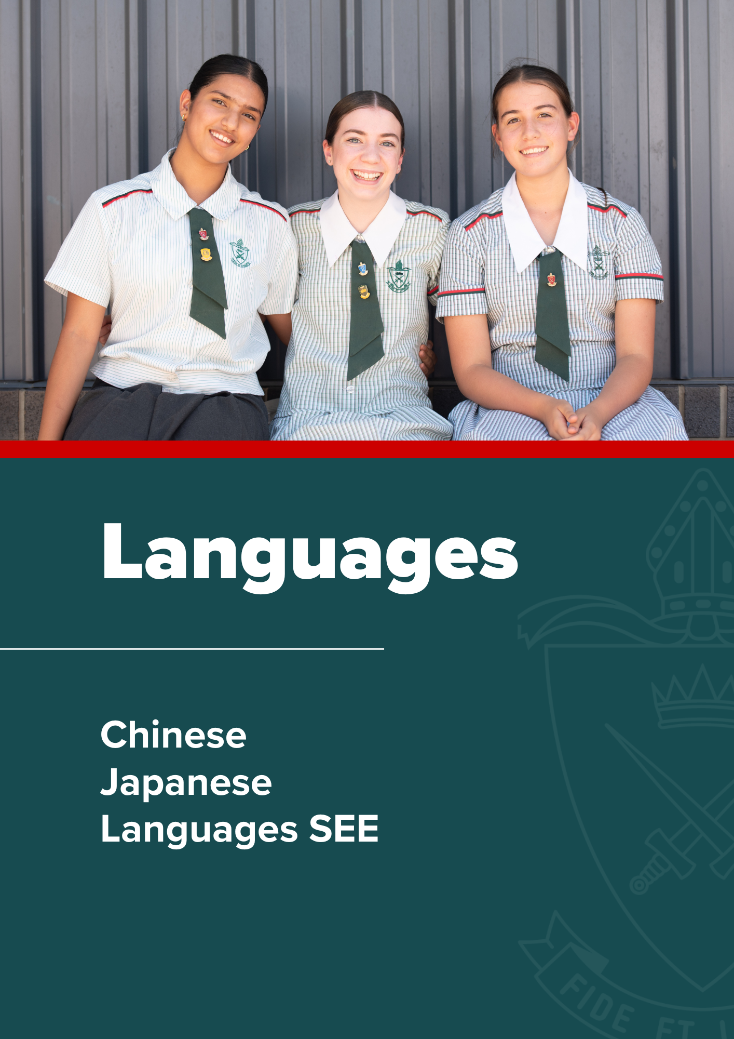
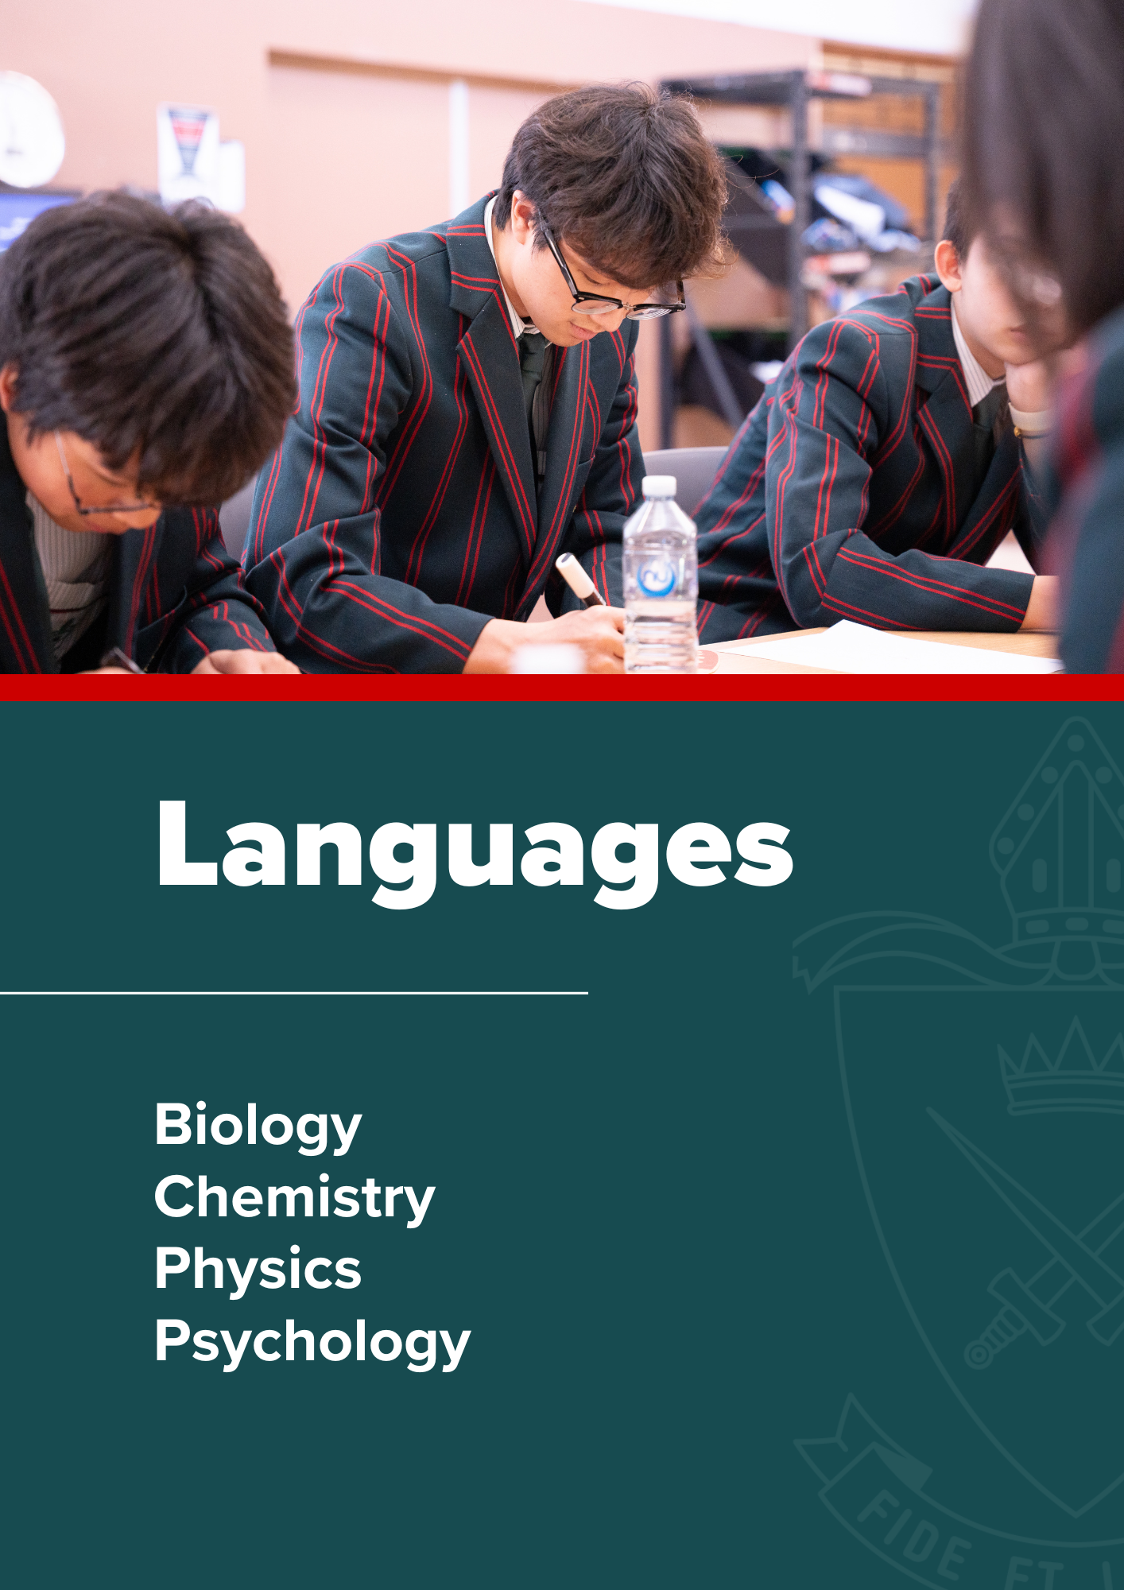

Languages

Chinese | General Subject

Rationale
The need to communicate is the foundation for all language development. People use language to achieve their personal communicative needs – to express, exchange, interpret and negotiate meaning, and to understand the world around them. The central goal for additional language acquisition is communication. Students do not simply learn a language – they participate in a range of interactions in which they exchange meaning and become active participants in understanding and constructing written, spoken and visual texts. Chinese is the study of communication that comes across a range of contexts for a range of purposes. In Unit 1, students compare and contrast lifestyles and education in Australian and Chinese-speaking communities, schools, homes and peer-group contexts. In Unit 2, students move beyond their personal world to how they engage with the world. They do this by exploring options for personal travel and tourism in Chinese-speaking countries and Australia, and by considering the associated cultural conventions. In Unit 3, students investigate their place in society. They reflect on roles and relationships in society and how they and their peers retain a sense of connectedness and belonging. In Unit 4, students focus on their final year of school and their post- school future. This includes end-of-school celebrations, students’ plans for their immediate future and how these plans, responsibilities and aspirations compare with those of young Chinese speakers.

Chinese aims to develop students’:
- understanding of a language and the communities that use it, while also assisting in the effective negotiation of experiences and meaning across cultures and languages;
- ability to reorganise their thinking to accommodate other linguistic and intercultural knowledge and textual conventions;
- ability to explore cultural diversity and similarities between another language and their own;
- critical and creative thinking and encourage them to use language in a meaningful way through the exchange of information, ideas and perspectives relevant to their life experiences; and
- knowledge, understanding and skills that enable successful participation in a global society. Communication in an additional language is an important 21st century skill that expands students’ horizons and opportunities as national and global citizens.

Pathways
Chinese is a General subject suited to students who are interested in pathways beyond school that lead to tertiary studies, vocational education or work. A course of study in Chinese can establish a basis for further education and employment in many professions and industries. For example, those which value the knowledge of an additional language and the intercultural understanding it encompasses, such as business, hospitality, law, science, technology, sociology and education. It will also be a benefit for those wishing to travel to Chinese-speaking countries for either business or recreational purposes.

Objectives
By the conclusion of the course of study, students will:
- comprehend Chines to understand information, ideas, opinions and experiences
- identify tone, purpose, context and audience to infer meaning
- analyse and evaluate information and ideas to draw conclusions
- apply knowledge of language elements of Chinese to construct meaning
- structure, sequence and synthesise information to justify opinions and perspectives
- communicate using contextually appropriate Chinese.

Course Structure
Unit 1 | Unit 2 | Unit 3 | Unit 4
我的世界  My world  - Family/carers  - Peers  - Education | 探索世界  Exploring our world  - Travel and exploration  - Social Customs  - Chinese influences around the world | 我们的社会; 文化和特性 Our society, culture and identity  - Lifestyles and leisure  - The arts, entertainment and sports  - Groups in society | 我的现在和未来  My present; my future  - The present  - Future choices

Assessment
Schools devise assessments in Units 1 and 2 to suit their local context. In Units 3 and 4 students complete four summative assessments. The results from each of the assessments are added together to provide a subject score out of 100. Students will also receive an overall subject result (A-E).
Unit 3 |  | Unit 4
Summative internal assessment 1 (IA1):  - Examination – short response | 15% | Summative internal assessment 3 (IA3):  - Extended response - Multimodal presentation and interview | 30%
Summative internal assessment 2 (IA2):  - Examination – combination response | 30% | Summative external assessment (EA):  - Examination – combination response | 25%

Japanese | General Subject

Rationale
The need to communicate is the foundation for all language development. People use language to achieve their personal communicative needs – to express, exchange, interpret and negotiate meaning, and to understand the world around them. The central goal for additional language acquisition is communication. Students do not simply learn a language – they participate in a range of interactions in which they exchange meaning and become active participants in understanding and constructing written, spoken and visual texts. Japanese is the study of communication that comes across a range of contexts for a range of purposes. In Unit 1, students compare and contrast lifestyles and education in Australian and Japanese-speaking communities, schools, homes and peer-group contexts. In Unit 2, students move beyond their personal world to how they engage with the world. They do this by exploring options for personal travel and tourism in Japanese-speaking countries and Australia, and by considering the associated cultural conventions. In Unit 3, students investigate their place in society. They reflect on roles and relationships in society and how they and their peers retain a sense of connectedness and belonging. In Unit 4, students focus on their final year of school and their post- school future. This includes end-of-school celebrations, students’ plans for their immediate future and how these plans, responsibilities and aspirations compare with those of young Japanese speakers.

Japanese aims to develop students’:
- understanding of a language and the communities that use it, while also assisting in the effective negotiation of experiences and meaning across cultures and languages;
- ability to reorganise their thinking to accommodate other linguistic and intercultural knowledge and textual conventions;
- ability to explore cultural diversity and similarities between another language and their own;
- critical and creative thinking and encourage them to use language in a meaningful way through the exchange of information, ideas and perspectives relevant to their life experiences; and
- knowledge, understanding and skills that enable successful participation in a global society. Communication in an additional language is an important 21st century skill that expands students’ horizons and opportunities as national and global citizens.

Pathways
Japanese is a General subject suited to students who are interested in pathways beyond school that lead to tertiary studies, vocational education or work. A course of study in Japanese can establish a basis for further education and employment in many professions and industries. For example, those which value the knowledge of an additional language and the intercultural understanding it encompasses, such as business, hospitality, law, science, technology, sociology and education. It will also be a benefit for those wishing to travel to Japanese-speaking communities for their business or recreational purposes.

Course Structure
Unit 1 | Unit 2 | Unit 3 | Unit 4
私のくらし  My world  - Family/carers  - Peers  - Education | 私達の世界をたんけんする  Exploring our world  - Travel and exploration  - Social Customs  - Japanese influences around the world | 私達の社会、  文化とアイデンティティ Our society; culture and identity  - Lifestyles and leisure  - The arts, entertainment and sports  - Groups in society | 私の現在と将来  My present; my future  - The present  - Future choices

Assessment
Schools devise assessments in Units 1 and 2 to suit their local context. In Units 3 and 4 students complete four summative assessments. The results from each of the assessments are added together to provide a subject score out of 100. Students will also receive an overall subject result (A-E).

Summative internal assessment 1 (IA1)  - Examination – short response | 15% | Summative internal assessment 3 (IA3)  - Extended response - Multimodal presentation and interview | 30%
Summative internal assessment 2 (IA2)  - Examination – combination response | 30% | Summative external assessment (EA)  - Examination – combination response | 25%

Languages SEE | General Subject

Rationale
The Senior External Examination is a program of individual subject examinations offered to eligible Year 12 students. Students who have a background second language can apply to do the Senior External Examination (SEE) languages subjects. Candidates must complete both SEE 1 (spoken component) and SEE 2 (written component) to receive a result.

QCAA administers assessments for the following subjects:
- Chinese SEE
- Indonesian SEE
- Korean SEE
- Vietnamese SEE

The SEE 1 examination for these subjects consists of:
- a prepared, individual, multimodal presentation to a QCAA examiner (8-10 minutes duration)
- an unprepared candidate-centred conversation with the examiner (7-8 minutes duration).

Other jurisdictions administer assessments for the following subjects:
- Arabic SEE
- Modern Greek SEE
- Polish SEE
- Punjabi SEE
- Russian SEE
- Latin SEE
There is no SEE 1 (spoken) component for Latin.
The spoken component for the remaining SEE languages subjects from other jurisdictions includes both:
- a conversation (approximately 7 minutes)
- a discussion (approximately 8 minutes).

Assessment
All assessment in these syllabuses will be based on the learning across both Units 3 and 4 and will be conducted through external examination. Examinations require assumed knowledge from Units 1 and 2.
Each language examination consists of a written and an oral component, completed on different days.
Students must sit both components.
All oral examinations will be recorded.

Course Structure
Unit 1 | Unit 2 | Unit 3 | Unit 4
My world  - Family/carers and friends  - Lifestyle and leisure Education | Exploring our world  - Travel  - Technology and media  - The contribution of culture to the world | Our society  - Roles and relationships  - Socialising and connecting with my peers  - Groups in society | My future  - Future pathways, plans and reflections  - Responsibilities and moving on

Assessment
Schools/providers devise assessment in Units 1 and 2 to suit their local context.
In Units 3 and 4 students/candidates complete two summative external assessments at the end of the course. The results from these two assessments are added together to provide a subject score out of 100.
Unit 3 | Unit 4
Summative external examination 1 (SEE 1): Extended response |  | 25%
Summative external examination 2 (SEE 2): Combination response |  | 75%

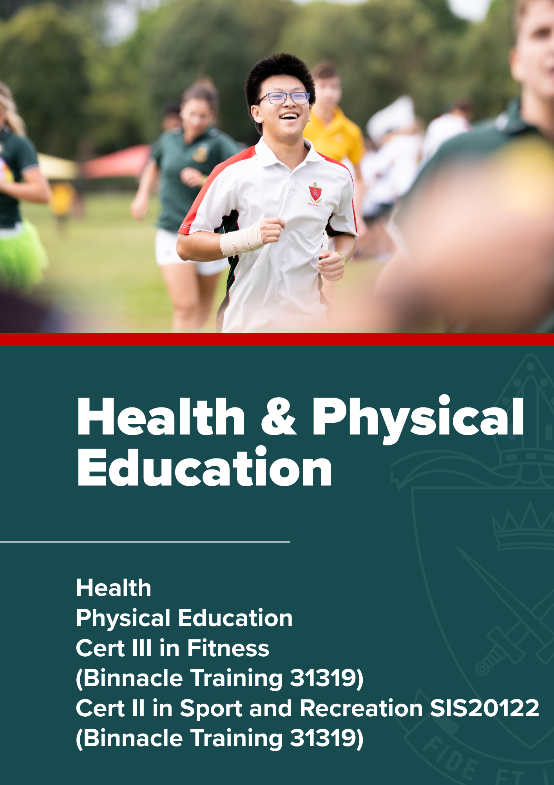

Health & Physical Education

Health | General Subject

Rationale
The knowledge, understanding and skills taught through Health and Physical Education enable students to explore and enhance their own and others’ health and physical activity in diverse and changing contexts. Development of the physical, intellectual, social, emotional and spiritual capacities necessary in the strands of ‘Movement and physical activity’ and ‘Personal, social and community health’ are key components of the P–10 Australian Curriculum: Health and Physical Education. They provide the foundations for learning and alignment to the QCAA Physical Education and Health senior syllabuses, to build increasingly complex and developmental courses of study in the senior years.

The Health syllabus is developmental and becomes increasingly more complex across the four units through the use of overarching approaches, frameworks and resources. This syllabus is underpinned by a salutogenic (strengths-based) approach, which focuses on how health resources are accessed and enhanced. Resilience as a personal health resource in Unit 1, establishes key teaching and learning concepts, which build capacity for the depth of understanding over the course of study. Unit 2 focuses on the role and influence of peers and family as resources through one topic selected from two choices: Elective topic 1: Alcohol, or Elective topic 2: Body image. Unit 3 explores the role of the community in shaping resources through one topic selected from three choices: Elective topic 1: Homelessness, Elective topic 2: Road safety, or Elective topic 3: Anxiety. The culminating unit challenges students to investigate and evaluate innovations that influence respectful relationships to help them navigate the post-schooling life-course transition.

Pathways
Health is a General subject suited to students who are interested in pathways beyond school that lead to tertiary studies, vocational education or work. A course of study in Health can establish a basis for further education and employment in the fields of health science, public health, health education, allied health, nursing and medical professions.

Course Structure
Unit 1 | Unit 2 | Unit 3 | Unit 4
Resilience as a personal health resource | Peers and family as resources for healthy living  - Elective topic 1: Alcohol and other drugs  - Elective topic 2: Body Image | Community as a resource for healthy living  - Elective topic 1: Homelessness  - Elective topic 2: Transport safety  - Elective topic 3: Anxiety | Respectful relationships in the post-schooling transition

Assessment
Schools devise assessments in Units 1 and 2 to suit their local context. In Units 3 and 4 students complete four summative assessments. The results from each of the assessments are added together to provide a subject score out of 100. Students will also receive an overall subject result (A-E).

Summative internal assessment 1 (IA1):  - Investigation – action research | 25% | Summative internal assessment 3 (IA3):  - Investigation – analytical exposition | 25%
Summative internal assessment 2 (IA2):  - Examination – extended response | 25% | Summative external assessment (EA):  - Examination | 25%

Physical Education | General Subject

Rationale
The knowledge, understanding and skills taught through Health and Physical Education enable students to explore and enhance their own and others’ health and physical activity in diverse and changing contexts. Development of the physical, intellectual, social and emotional capacities necessary in the strands of ‘Movement and physical activity’ and ‘Personal, social and community health’ is a key component of the P–10 Australian Curriculum: Health and Physical Education. It provides the foundations for learning and alignment to the Physical Education and Health senior syllabuses to build increasingly complex and developmental courses of study in the senior years.

The Physical Education syllabus is developmental and becomes increasingly complex across the four units. In Unit 1, students develop an understanding of the fundamental concepts and principles underpinning their learning of movement sequences and how they can enhance movement from a biomechanical perspective. In Unit 2, students broaden their perspective by determining the psychological factors, barriers and enablers that influence their performance and engagement in physical activity. In Unit 3, students enhance their understanding of factors that develop tactical awareness and influence ethical behaviour of their own and others’ performance in physical activity. In Unit 4, students explore energy, fitness and training concepts and principles to optimise personal performance.

Pathways
Physical Education is a General subject suited to students who are interested in pathways that lead to tertiary studies, vocational education or work. A course of study in Physical Education can establish a basis for further education and employment in the fields of exercise science, biomechanics, the allied health professions, psychology, teaching, sport journalism, sport marketing and management, sport promotion, sport development and coaching.

Course Structure
Unit 1 | Unit 2 | Unit 3 | Unit 4
Motor learning, functional anatomy, biomechanics and physical activity  - Motor learning integrated with a selected physical activity  - Functional anatomy and biomechanics integrated with a selected physical activity | Sport psychology, equity and physical activity  - Sport psychology integrated with a selected physical activity  - Equity – barriers and enablers | Tactical awareness, ethics and integrity and physical activity  - Tactical awareness integrated with one selected ‘Invasion’ or ‘Net and Court’ physical activity  - Ethics and integrity | Energy, fitness and training and physical activity  - Energy, fitness and training integrated with one selected ‘Invasion’, ‘Net and court’ or ‘Performance’ physical activity

Assessment
Schools devise assessments in Units 1 and 2 to suit their local context. In Units 3 and 4 students complete four summative assessments. The results from each of the assessments are added together to provide a subject score out of 100. Students will also receive an overall subject result (A-E).

Unit 3 |  | Unit 4
Summative internal assessment 1 (IA1):  - Project – folio | 25% | Summative internal assessment 3 (IA3):  - Project - folio | 25%
Summative internal assessment 2 (IA2):  - Investigation – report | 25% | Summative external assessment (EA):  - Examination – combination response | 25%

Required Equipment
Plastic Display Folder
Standard HPE clothing

Cert III in Fitness - SIS30321 (Binnacle Training RTO 31319) | VET Subject

Cert II in Sport and Recreation - SIS20122 (Binnacle Training RTO 31319) | VET Subject

Rationale
This will be a stand-alone VET subject which will encompass Certificate II in Sport and Recreation and Certificate III in Fitness in Year 11 and Year 12. Both Certificates upon successful completion will be awarded by Binnacle Training, an external Registered Training Organisation (RTO).
The Certificate II in Sport and Recreation includes both practical and theoretical components relating to the coaching of various sports, physical activities and for various clientele in group settings.
The Certificate III in Fitness course is designed to equip you with the knowledge and skills to perform the duties of a gym, group or aqua instructor at a commercial gym. The course provides you with an extensive knowledge of exercise principles which enable you to fully understand the effect of exercise on the body and therefore to write and adapt programs to suit the specific needs of individuals, groups or teams. You will be able to adapt programs to suit various environments as well as provide technical advice on equipment and exercise techniques.
Physical Education and Health - Fitness Studies is seen as complementary to both these Senior subjects with some of the material common to both subjects.
Assessment for the course is both theory and practically based. Theoretical components of the course will involve short and long answer responses and multiple-choice responses. Practical components will be assessed using scenario-based situations, role plays, client screening, planning and conducting fitness tests and fitness sessions.
This is a competency-based course. This means that students work to develop the competencies, skills and knowledge described in each Unit of Competency. To be assessed as competent a student must demonstrate to a qualified assessor that they can effectively carry out the various tasks and combinations of tasks listed to the standard required in the appropriate industry. There is no mark awarded in competency-based assessment. Students are assessed as either 'competent' or 'not yet competent'. Students will be progressively assessed in individual Units of Competency. When a student achieves a Unit of Competency it is signed off by the assessor in a Student Profile Sheet.

Pathways
Work in a gym, leisure centre, on a cruise ship, PT studio, outdoors, at a holiday resort of health spa or even run your own business! Your career pathways are endless. In addition to gaining the appropriate VET Certificates, there are the below QCE benefits of this subject offering:
- Certificate III in Fitness attracts 8 credit points
- One nationally recognised qualification necessary for industry recognition and Fitness Australia membership: The Certificate III of Fitness (Fitness Instructor)
- Senior First Aid Certificate
- Valuable work experience during the two years in this industry
- Registration as a Fitness Instructor is valid Australian wide

Course Structure
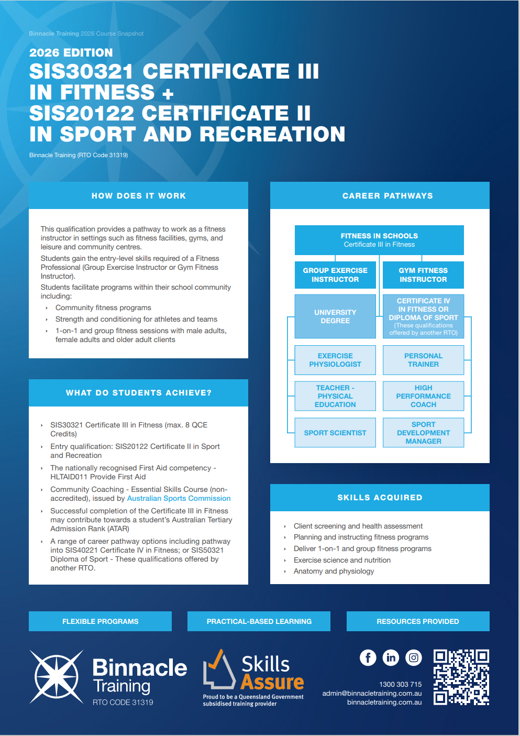

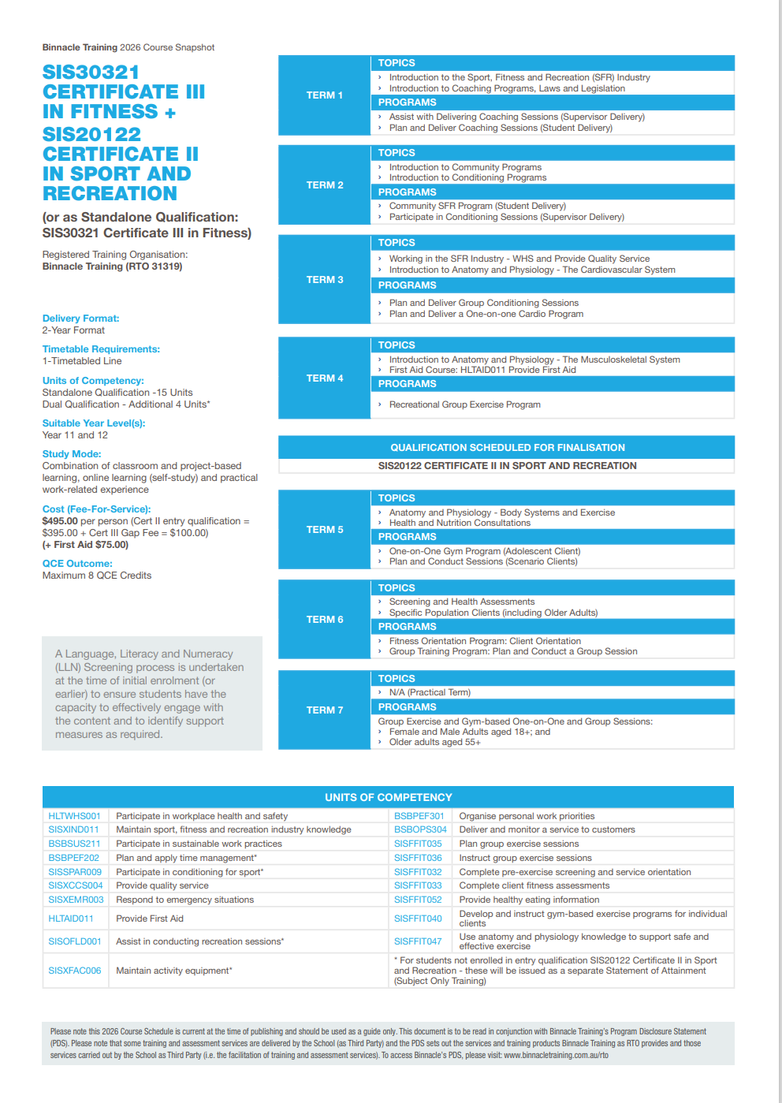

Student Activities
- Teacher exposition of theoretical concepts.
- Full class discussion.
- Training program development and analysis.
- Analysis of case studies/scenarios.
- Small group work.
- Please be aware that this subject involves a theoretical component (50%). The practical component involves work in the gym to screen clients and build programs for them, as well as individual fitness participation (50%).
A Language, Literacy and Numeracy (LLN) Screening process is undertaken at the time of initial enrolment (or earlier) to ensure students have the capacity to effectively engage with the content and to identify support measures as required.

This document is to be read in conjunction with Binnacle Training’s Program Disclosure Statement (PDS). The PDS sets out the services and training products Binnacle Training as RTO provides and those services carried out by the School as Third Party (i.e. the facilitation of training and assessment services). To access Binnacle’s PDS, please visit: binnacletraining.com.au/rto

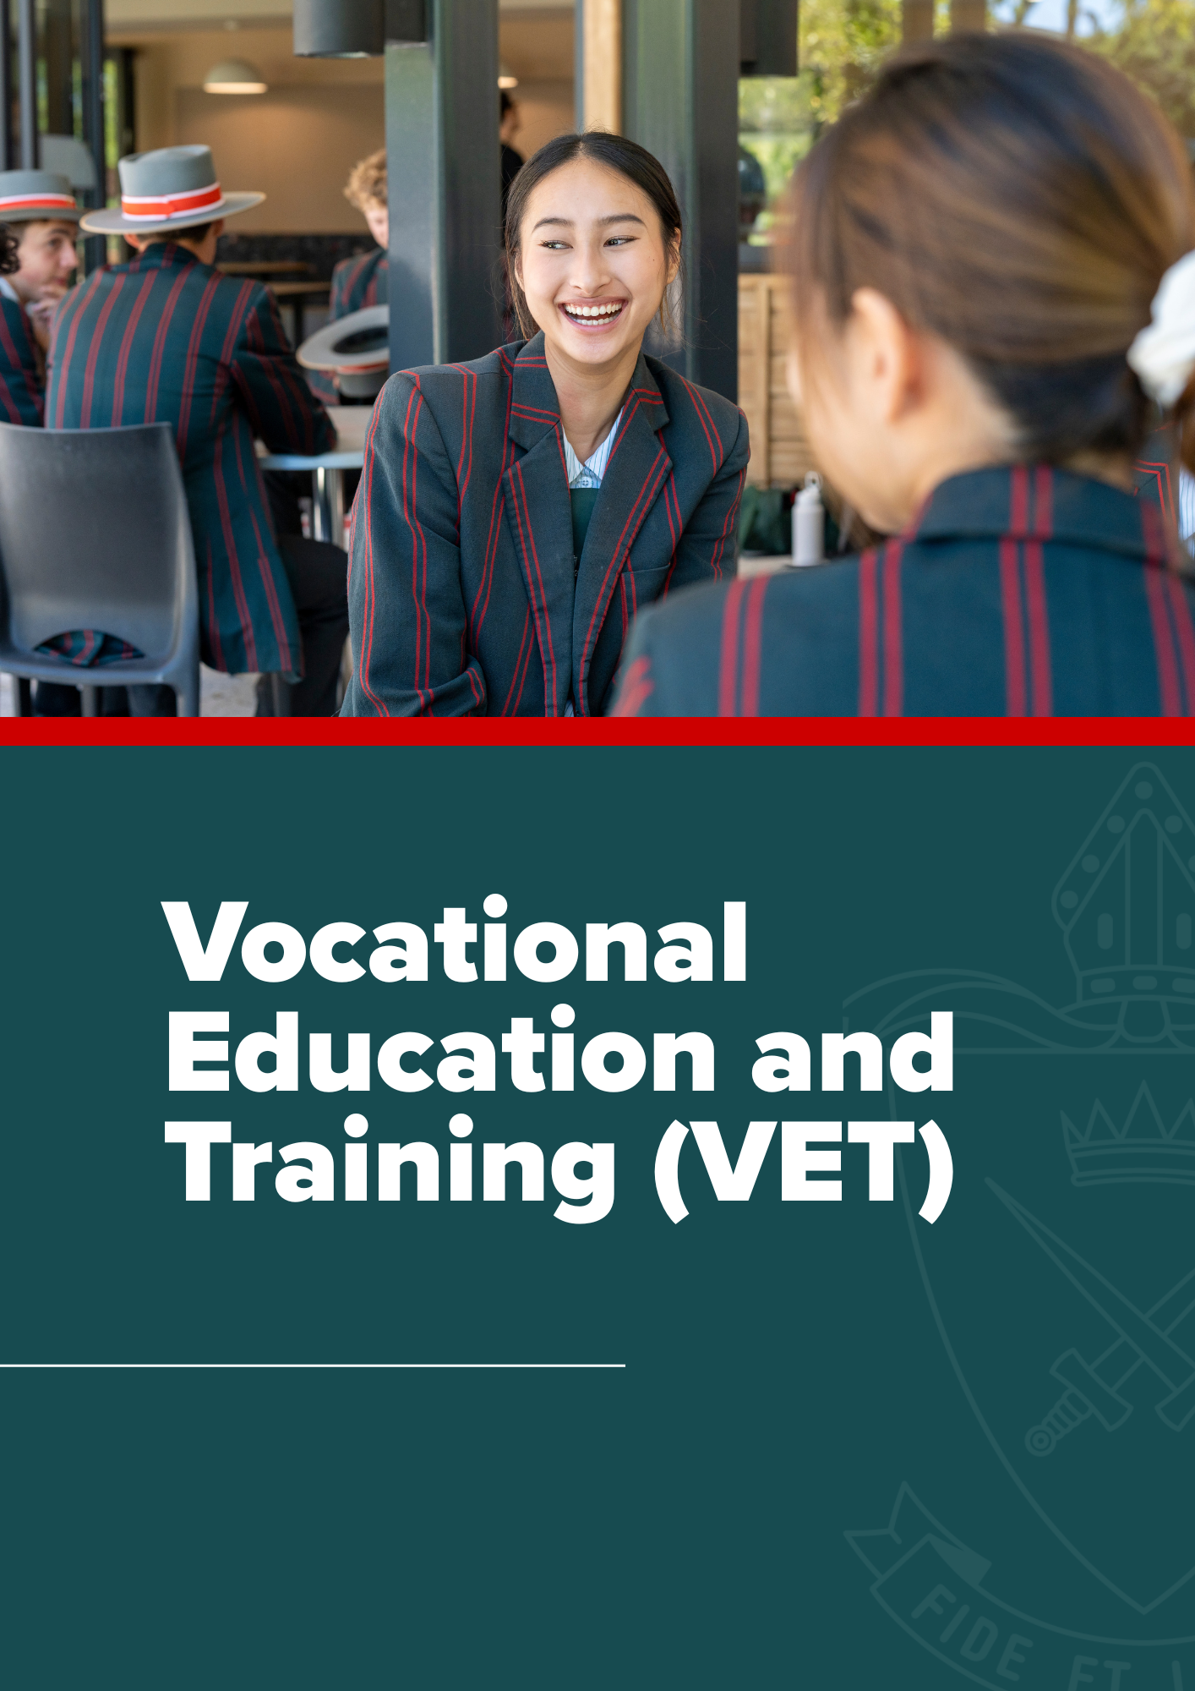

Vocational Education & Training (VET)

Vocational Education & Training (VET) | VET in Schools

Vet in Schools Programs
‘VET in Schools’ refers to Vocational Education and Training (VET) in Schools programs undertaken as part of a senior secondary certificate. VET in Schools programs allow you to earn credit towards a nationally recognised qualification, while you complete the general education curriculum for your Queensland Certificate of Education (QCE). VET qualifications will also contribute credit points to your QCE.
Please Note: Unfortunately, Full-Fee Paying Overseas Students (FFPOS) are unable to undertake a TAFE course off the School campus.

With VET in Schools, you can:
- combine a vocational pathway with your general education curriculum
- work towards a Certificate I, II or III, or sometimes even a Certificate IV qualification
- keep your options open to pursue further vocational education (such as courses at a Technical and Further Education (TAFE) institute, or move into higher education (such as undertaking courses at university)
- gain work experience

Before commencement of a VET course, students will receive the following information:
- VET student handbook
- VET consent form
- course content and assessment requirements

Courses that are conducted and awarded by an external Registered Training Organisation (RTO).
- Certificate III in Fitness Studies – SIS30310
- Certificate III in Music Industry – CUA30915

(Refer to the Course Outlines which appear in the subject’s selection later in this handbook).

VET in School Programs and School Based Traineeship/Apprenticeships are generally scheduled to coincide with school hours, and students need to sign a declaration that lesson content missed from the timetable will need to be made up in the allocated VET Study lessons.

What does our School offer in VET in Schools Programs?
Courses that are conducted and awarded by an external Registered Training Organisation (RTO).
- SIS30315 Certificate III in Fitness (Binnacle Training 31319)
- Certificate II in Sport and Recreation (Binnacle Training 31319)
- Certificate III in Hospitality SIT30616
- Certificate III in Music– CUA30915

(Refer to the Course Outlines listed within each learning area outlined previously).

VET in School Programs and School Based Traineeship/Apprenticeships are generally scheduled to coincide with school hours, and students need to sign a declaration that lesson content missed from the timetable will need to be made up in the allocated VET Study lessons.

How do I nominate VET in my Subject Selection Form?
Select the VET course you would like to undertake in the Subject Selection Form.

What are Australian Apprenticeships?
Australian Apprenticeships (often referred to as traineeships and apprenticeships) are a great career option. They combine practical work with structured training to give you a nationally recognised qualification and the experience you need to get the job you want. Training is flexible and can be on-the-job, off-the-job or a combination of both. Australian Apprenticeships are available at a variety of qualification levels in most occupations, as well as in traditional trades and a wide range of emerging industry sectors.
You do not have to wait until you leave school to get started. Australian School Based Apprenticeships can be included in a student’s pathway at St Paul’s School, giving students the option of starting while still at school.

To start an Australian Apprenticeship (either Traineeship or Apprenticeship) students must have their own employer contact.

How do I get started finding a School-Based Traineeship/Apprenticeship?
- Consult one of the School Counsellors to discuss your career plans and interests;
- Find work experience to see if you like the area;
- Find an employer;
- The School Counsellors may refer you to the School VET Administrator to assist with your application.

Can I still receive an ATAR if I take up a VET option?
A student undertaking four General subjects and one Applied subject or VET subject (Cert III or greater) is still eligible for an ATAR.

Cost of VET programs
VET embedded into the curriculum | • | no extra parent contribution
VET courses offered by VET in Schools Program via TAFE | • | depending on selection of course, fees may vary. There are courses on offer that attract no extra parent contribution
VET courses offered by Private Training Organisation | • | extra parent contribution*
School-based Australian Apprenticeships | • | no extra parent contribution

What time does my VET external/internal VET Course Start?
VET in School Programs and School Based Traineeship/Apprenticeships are generally scheduled to coincide with school hours, therefore it is likely that time missed from a student’s timetable will need to be made up in their own time.

NOTE: The QCAA Student Portal will confirm exact QCE points on courses.

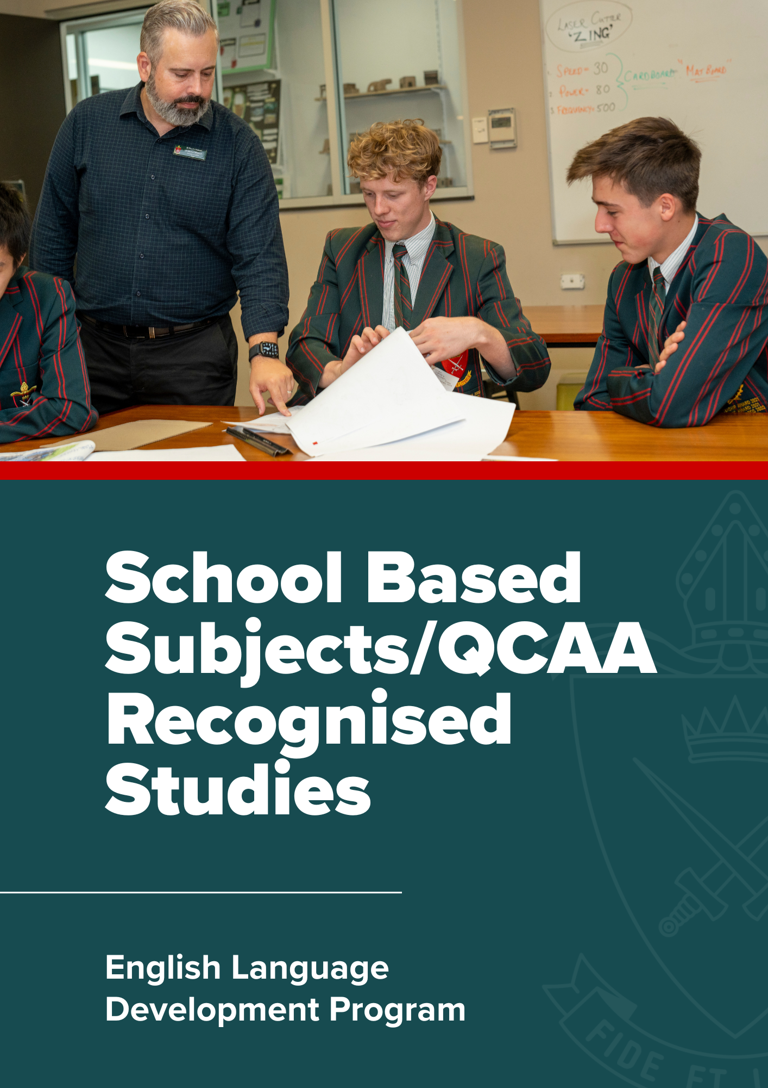

School Based Subjects/QCAA Recognised Studies

English Language Development Program | School-Based Subject

Rationale
In Australian schools, learning is accessed through English, and achievement is demonstrated through English. Each area of the curriculum has language structures and vocabulary particular to its learning domain, and these are best taught in the context in which they are used (ACARA, 2014). Second language learners require specific support to build the English language skills necessary to access the range of syllabus that form part of the Queensland Curriculum and Assessment Authority’s QCE system. According to Cummins (1979) Cognitive Academic Language Proficiency takes a second language learner a minimum of 5-7 years to develop intermediate fluency.
The senior secondary English Language Development program provides an opportunity for second language learners to continue the development of their English language skills. The lessons provide an opportunity for students to work collaboratively with their peers or individually with their teacher to better understand their classroom work and assessment. Students have opportunities to ask questions, clarify task instructions and seek help with planning and drafting for subject specific assessment. This course is highly recommended for all second language learners.

