**COUNSELLING**

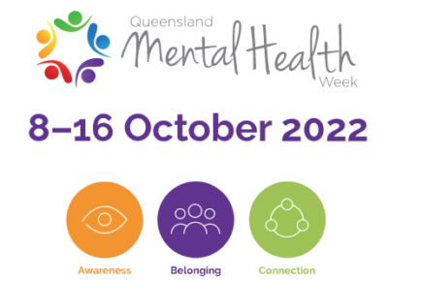

**MENTAL HEALTH WEEK**

The theme for Queensland Mental Health Week this year is ‘Awareness, Belonging and Connection’. This is critical to supporting our positive mental health and wellbeing.

* *Awareness* is about understanding the things we need to maintain and boost our mental wellbeing and knowing when we need to reach out for help and where to get it.
* *Belonging* is about looking out for each other, ensuring we feel safe and supported, and understanding that however we feel, we’re not alone, and that there are others going through the same thing.
* *Connection* is about our relationships with our friends, families, and those that we care about, as well as the groups, clubs, and networks around us that we rely on to help keep us happy and healthy, wherever we live, work, or play.

We all have Mental Health! And in our busy lives, we need to find space to look after ourselves. That will look different for each one of us but regularly finding space in our lives to do things we enjoy or do the things that recharge us will give us the best chance of having positive mental health.

**HELPFUL CONTACTS**

* Beyond Blue 1300 22 4636
* Lifeline 13 11 14
* Kids Helpline 1800 55 1800.
* Youth Beyond Blue <http://www.youthbeyondblue.com/>

**CAREERS**

**ST PAUL’S SCHOOL CAREERS WEBSITE**

Did you know that we have a SPS Careers Website?  You can find it on the School Portal or at <https://www.stpaulscareers.com.au/>.  Check out the Important Info section that has a Calendar of Events from Universities, Defence, TAFE, Expo’s etc!

To see the latest Career Tools Newsletter click [here](https://stpauls4.sharepoint.com/sites/ADM_Counselling/Shared%20Documents/General/CAREER%20TOOLS/Newsletter/t3_wk8_2022.pdf) or you can view the SPS Career Tools Weekly [here](https://stpauls4.sharepoint.com/sites/ADM_Counselling/Shared%20Documents/General/CAREER%20TOOLS/SPS%20Career%20Tools%20Weekly7_29.8.22.pdf). To view earlier editions of the Weekly on the website click [here](https://www.stpaulscareers.com.au/important-information/school-newsletters).