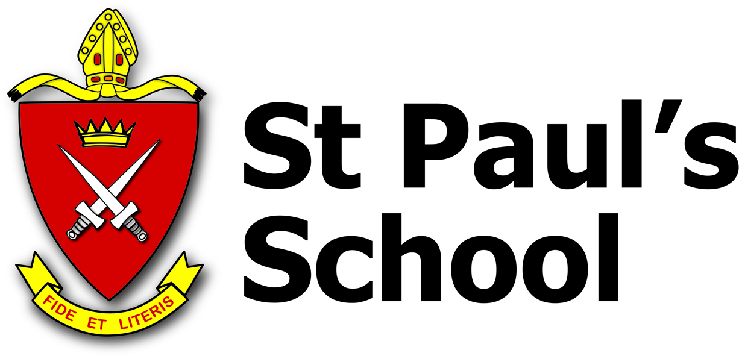
EXPRESSION OF INTEREST FORM:
OUTREACH TRIP TO VANUATU, 2023

After a recent, successful, fact-finding trip to Vanuatu, to look at the infrastructure and supply situation compared to pre Covid times, and to re-establish face to face links with the staff and students of the communities we visit on our Outreach trips. Headmaster, Dr Browning has given permission to begin planning and preparation for the re-commencement of Outreach Trips to Vanuatu beginning again in 2023.
We are seeking Expressions of Interest from students in years 10-12 in 2023, who would be interested in possibly participating in the trip.
Please understand this is not an application form but an expression of interest so you will be kept informed of opportunities to learn more details about the trip.

Please also be advised there will be an Information evening in the Chapel of St Paul’s on 1st November 2022 at 6:30 pm - 7:15 pm which will be very advantageous to attend for interested parties. (Applications may be available at the conclusion of the evening.)

EXPRESSION OF INTEREST: OUTREACH TRIP TO VANUATU, 2023

The Vanuatu Outreach departs in the last week of Term 2 and returns approx. 14 days later. (Dates to be confirmed) Accommodation is in a small resort on the island of Santo, from which we travel to surrounding villages and participate in activities with local schools and communities. The cost of the trip is fully inclusive of flights, meals, transport and accommodation and likely to be in the vicinity of $3500.

I am interested in finding out more information about the Outreach Trip to Vanuatu in 2023.

Child’s name (please print) ______________________________________________

Student Number ________________________ 2023 Grade/Class (Circle) Y10 Y11 Y12

House: _______________________

Parent’s signature: _______________________________________________________

Parent’s name (please print): _______________________________________________

Parent’s email contact address: ______________________________________

Please return this form to the Wellbeing Centre Att: Mrs Michelle Fraser, Extra Curricular Coordinator, or Rev. Mark Leam by 1.30 pm, Monday 31 October 2022.

