Notice of Annual General Meeting
of the Music Supporter Group
to be held on 7/03/2022
Notice is hereby given that the St Paul's School Music Supporter Group will hold its Annual General Meeting on 7/03/2022 at 6:30pm in the Music Room, Music Department. All Parents and Carers are welcome to attend this meeting and are eligible to both nominate for Committee positions and vote on the election of Officers.
Nominations are invited for the following positions on the Committee:
President & Vice President
Secretary
Treasurer
Committee Members
Nominations should be made in writing on the form below and lodged with the Secretary by heardsl@bigpond.net.au . All nominations must be proposed and seconded by persons eligible to vote at the subsequent elections. This can be done on the night of the meeting should you wish to nominate.
__________________________________________________________________________________
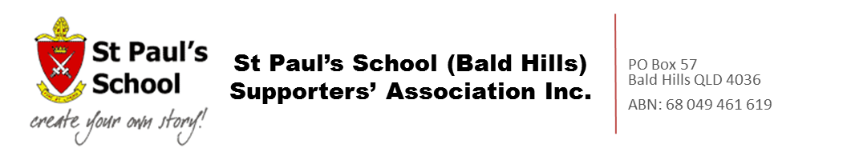
NOMINATION FORM – 2022
St Paul's School Music Supporters Group
Please complete and return this form to the Secretary (secretary@spssa.org.au) by 4/03/2022 or bring along to the meeting
POSITION: _______________________________________________________________
NOMINEE: ___________________________ __________________________________
(Print Name and Signature)
NOMINEES EMAIL: ________________________________________________________
NOMINATED BY: ______________________ ___________________________________
(Print Name and Signature)
SECONDED BY: ________________________ __________________________________
(Print Name and Signature)

